**Lecture 1 – Introduction to Data Science**

Data science is an interdisciplinary field about processes and systems to extract knowledge or insights from data in various forms

* **Historical View**: In 1962, statistician John Tukey described a field called "data analysis", which emerged out of statistics, but focusing not just on testing hypotheses, but on computing aspects of data analysis: including collecting, storing, analyzing, presenting data, etc.

**Infrastructure of Cloud Computing**

* Concept of Utility computing
  + Computing resources as a metered service (‘pay as you go’)
  + Ability to dynamically provision virtual machines
  + Allows for scalability: ‘infinite’ capacity
  + Elasticity: scale up/down on demand

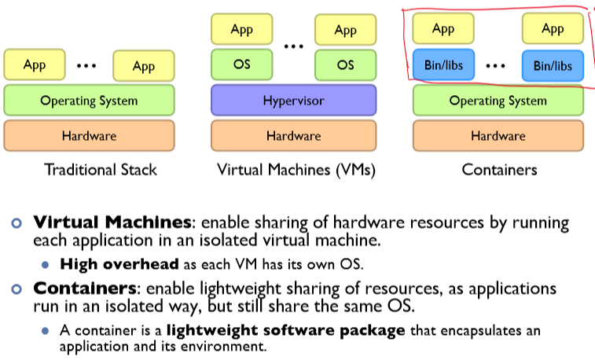

* Infrastructure as a Service: Utility Computing
  + Why buy machines when you can rent cycles?
  + Amazon EC2, Google Compute Engine, Rackspace
* Platform as a Service
  + Provides hosting for web applications and takes care of the hardware
  + Google App Engine
* Software as a Service
  + Example: Gmail, Dropbox, Zoom

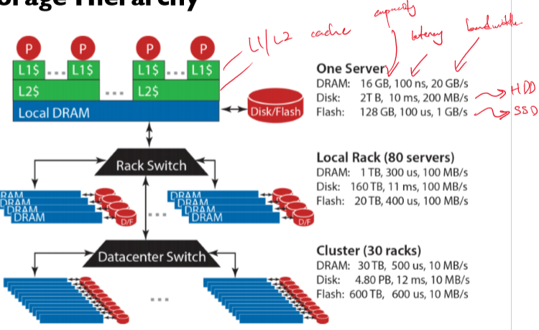

**Bandwidth**: maximum amount of data that can be transmitted per unit time (e.g. in GB/s)

**Latency**: time taken for 1 packet to go from source to destination (one-way) or from source to destination back to source (round trip), e.g. in ms

* When transmitting a large amount of data, bandwidth tells us roughly how long the transmission will take.
* When transmitting a very small amount of data, latency tells us how much delay there will be.

**Throughput** is similar to bandwidth, but instead of referring to capacity, it refers to the rate at which some data was actually transmitted across the network during some period of time.

**Lecture 2 – MapReduce**

Programmers typically specify two functions

* **map:** (k1, v1) 🡪 List(k2, v2)
* **reduce:** (k2, List(v2)) 🡪 List(k3, v3)
* All values with the same key are sent to the same reducer

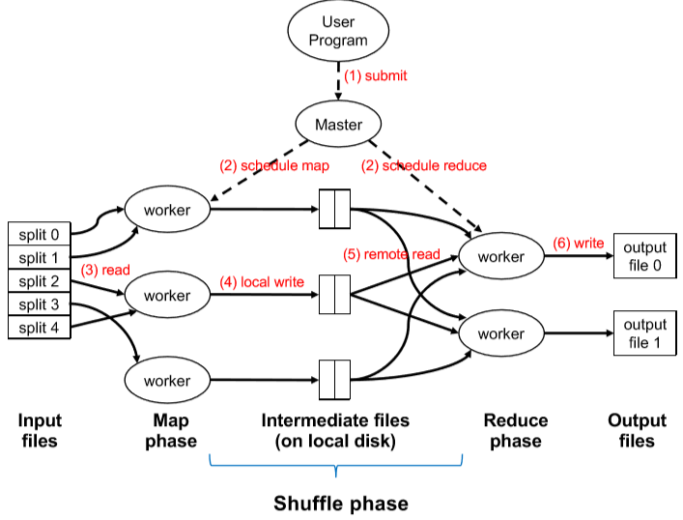

1. **Submit**: user submits MapReduce program (including code for the map and reduce functions) and configuration (e.g. no. of workers) to Master node.
2. **Schedule**: Master schedules resources for map and reduce tasks (Note: Master does not handle any actual data).
3. **Read**: Input files are separated into “splits” of around 128MB each.
   * Each split corresponds to one map task. Workers execute map tasks 1 at a time.
   * **Map phase**: Each worker iterates over each <key, value> tuple in its input split, and computes the map function on each tuple.
4. **Local write**: Each worker writes the outputs of the map function to intermediate files **on its own local disk**.
   * These files are partitioned by key (i.e. all the data for a single key is in one partition)
5. **Remote read**: Each reduce worker is responsible for 1 or more keys.
   * For each such key, it reads the data it needs from the corresponding partition of each mapper’s local disk.
   * This causes network I/O as the data is being read and shuffled from each mapper's disk
   * **Reduce phase**: After receiving all the needed key value pairs, it computes the reduce function.
6. **Write**: The output of the reduce function is written (usually to HDFS, a distributed file system).

Clarification of “shuffle phase”: the “shuffle phase” is comprised of the local write and remote read steps. Thus, it happens partly on the map workers, and partly on the reduce workers.

**Determining split size**

* If the split size is **too big**
  + Limited parallelism as less workers can work on splits
* If the split size is **too small**
  + Parallelism overhead dominates
  + Master node might become overwhelmed by scheduling

**Barrier between map and reduce phases**

* Reduce phase can only begin once Map phase completes
* However, shuffle phase can begin copying intermediate data over

**If a reduce task handles multiple keys, it will process these keys in sorted order**

**Partitioner and Combiner**

* Programmers can optionally specify the partition and combine function
* These are optional optimizations to reduce network traffic

**Partitioning**

Programmers can specify a partition function to better load balance the keys assigned to reducers

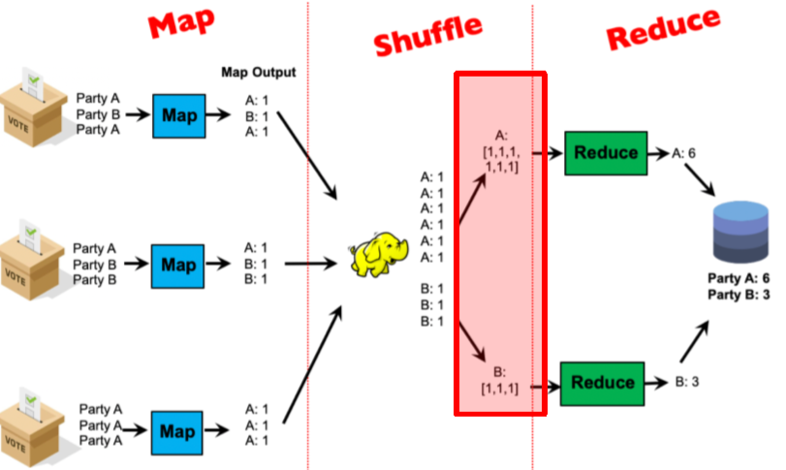

* The assignment of keys to reducers is determined by a hash function
  + e.g. key k goes to reducer: (hash(k) mod num_reducers)
* Users can optionally implement a custom partition to **better spread the load** among reducers

**Combiner**

Disk IO is expensive, and programmers can specify a combiner function to reduce the number of tuples emitted by the mapper before it is written to disk.

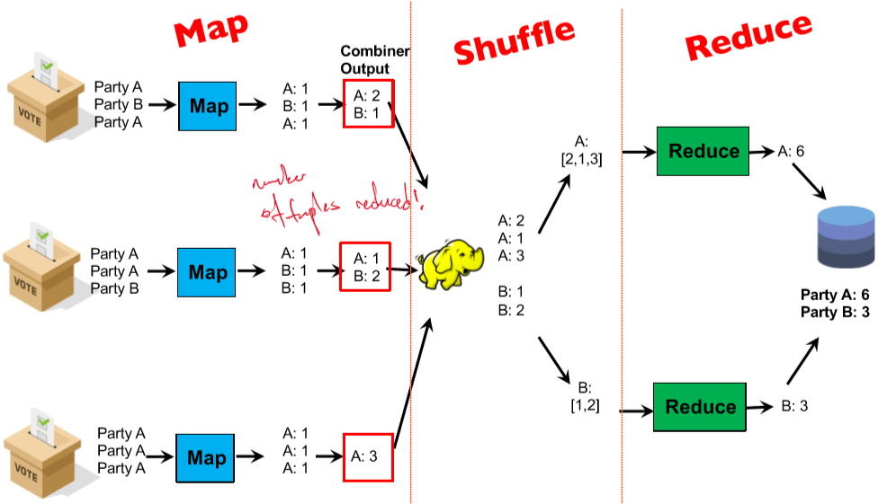

* Combiners locally aggregate output from mappers
* Combiners are ‘mini reducers’: in this example only, combiners and reducers are the same function
* **Correctness**
  + It is the user’s responsibility to ensure that the combiner does not affect the correctness of the final output, **whether the combiner runs 0, 1, or multiple times**.
    - i.e. the combiner must return the same output type as the mapper

**Preserving State in Map / Reduce Tasks**

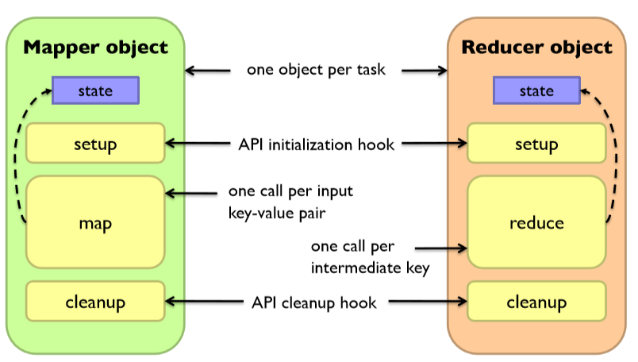

**Secondary Sort**

* Each reducer’s values arrive unsorted, but what if we want them to be sorted (e.g. sorted by temperature)
* Define a new ‘composite key’ as (K1, K2), where K! is the original key (“Natural Key”) and K2 is the variable we want to use to sort
  + Partitioner now needs to be customized to partition by K1 only, not K1, K2
    - Otherwise, the partitioner will partition them by the composite key K1,K2
* The MapReduce framework always sorts the data by key before giving it to each reducer

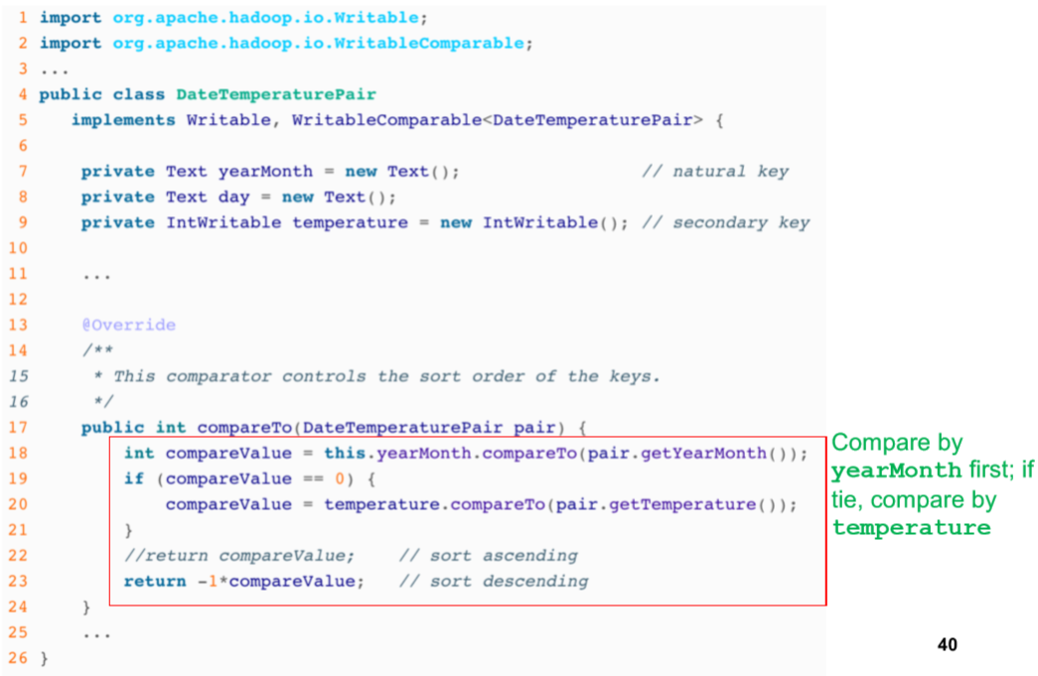

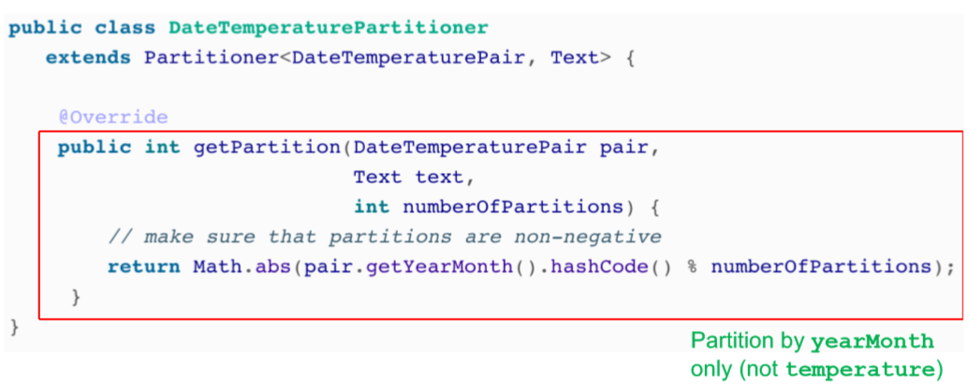

**Lecture 3 – Data Mining**

**Relational Databases**

* A relational database is comprised of tables
  + A table is also known as a relation, and is a collection of tuples (rows)
  + Each tuple consists of multiple fields

**A common scheme for organizing tables – Star Schema**

* Contains a fact table, which usually corresponds to some event
* Each field in the fact table usually contains an ID, which is a reference to another table

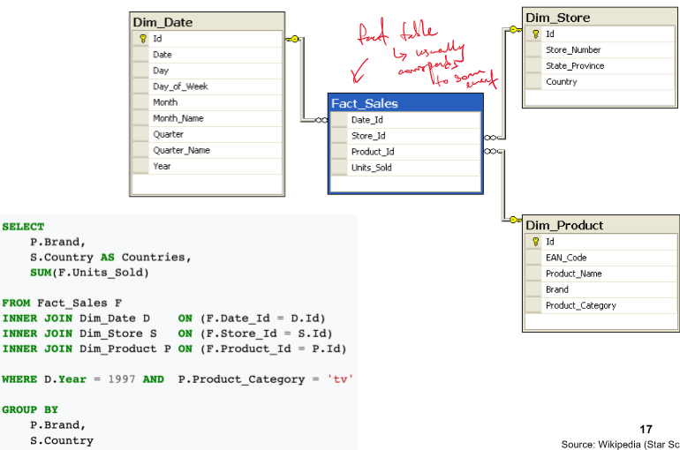

**Projection**

* $π$– is the projection symbol
* Projection operation *maps* a tuple and emits a new tuple with appropriate attributes

**Selection**

* $σ$– is the selection symbol
* Selection operation selects the tuples that meet a given predicate

**Inner Join**

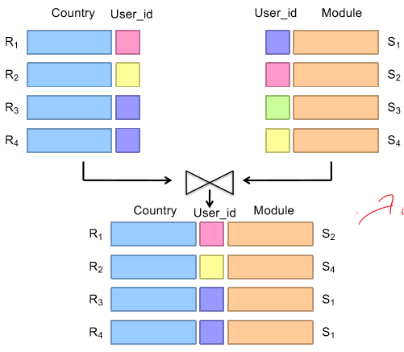

* Many-to-Many relationship
  + E.g. a particular user ID can appear multiple times in both tables

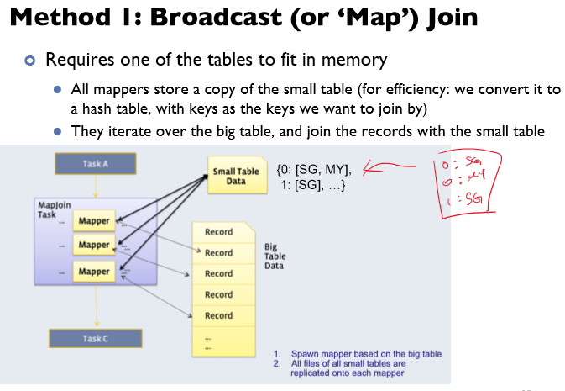

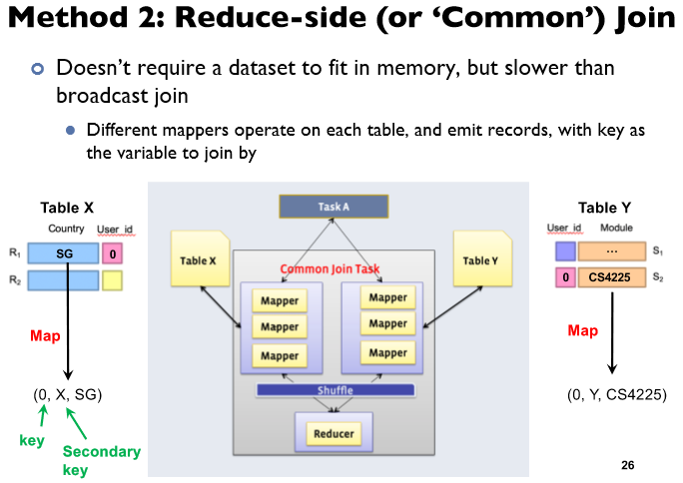

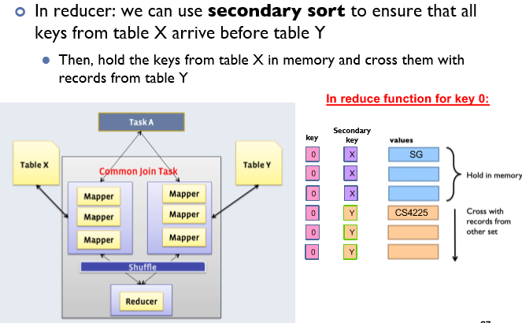

**Similarity Search**

* **Distance / Similarity metrics**
  + Euclidean Distance = $d\left(a,b\right)={\left|a-b\right|}_{2}=\sqrt{\sum_{i=1}^{D}{{\left(a_{i}-b_{i}\right)}^{2}}}$
  + Manhattan distance = $d\left(a,b\right)={\left|a-b\right|}_{1}=\sum_{i=1}^{D}{|a_{i}-b_{i}|}$
  + Cosine similarity = $s\left(a,b\right)=\cos{θ}=a∙b/|a||b|$
  + Jaccard similarity = $s_{jaccard}\left(A,B\right)=\frac{\left|A∩B\right|}{|A∪B|}$
    - Jaccard distance = $d_{jaccard}\left(A,B\right)=1-s_{jaccard}(A,B)$

**Finding similar documents**

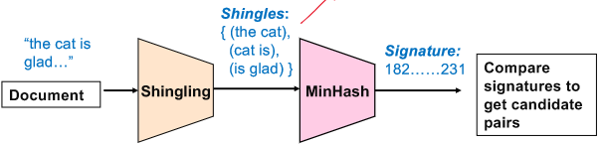

* **Shingling**  - converting document to sets of phrases (tokenization)
  + A k-shingle or (n-gram) for a document is a sequence of k tokens that appears in the doc
  + We can measure similarity between documents as using Jaccard similarity on the set of k-shingles
* **MinHash**
  + **Motivation**:
    - Suppose we have N = 1million documents. We would need to compute pairwise Jaccard similarities for every pair of docs, resulting in N(N-1)/2 operations
  + **Key Idea:**
    - Hash each shingle set to a small signature $h(C)$ such that it is small enough to fit into RAM
    - Highly similar documents will have the same signature
  + **Goal:** Find a hash function h such that
    - **If $sim\left(C_{1},C_{2}\right)$**  is high, then with high probability, $h\left(C_{1}\right)=h(C_{2})$
    - **If $sim\left(C_{1},C_{2}\right)$**  is low, then with high probability, $h\left(C_{1}\right)≠h(C_{2})$
  + **Steps:** Given a set of shingles { (the cat), (cat is), (is glad) }
    - Have a hash function that maps each shingle to an integer
    - Then compute the minimum of these hashes

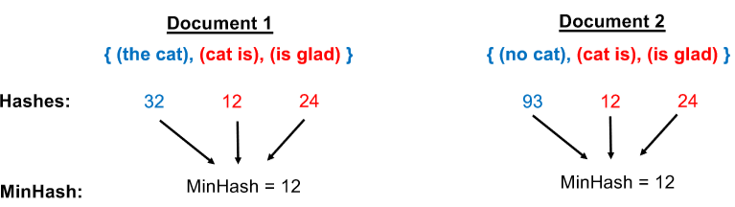

* + **Key Property**: The probability that two documents have the same MinHash signature is equal to their Jaccard Similarity
    - **Formally**: $\operatorname{Pr}\left[h\left(C_{1}\right)=h\left(C_{2}\right)\right]=JaccardSim(C_{1},C_{2})$
* **Final Step**
  + The documents with the same final signature are “candidate pairs”. We can either directly use them as our final output, or compare them one by one to check if they are actually similar pairs
  + In practice, we usually use multiple hash functions (N=100), and generate N signatures for each document. “Candidate pairs” can be defined as those matching a ‘sufficient’ number among these signatures
* **MapReduce Implementation**
  + Map phase
    - Read over the document and extract its shingles
    - Hash each shingle and take the min of them to get the MinHash Signature
    - Emit <signature, document_id>
  + Reduce phase
    - Receive all documents with a given MinHash Signature
    - Generate all candidate pairs from these documents
    - (Optional): Compare each such pair to check if they are actually similar

**KMeans Clustering**

* Pick K random points as centers
* Repeat
  + Assign each point to a cluster based on which cluster center it is nearest to
  + Move each cluster center to average of its assigned points
* Stop when no assignment changes

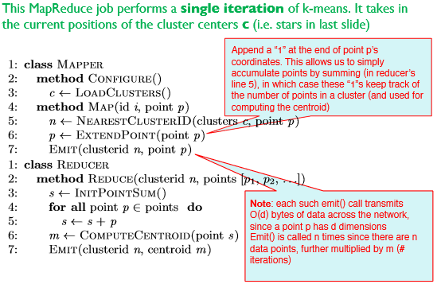

* O(nmd) disk I/O incurred, where n = number of points, m = number of iterations, d = dimensionality, k = number of clusters
* **Alternative implementation with in-mapper combiner**

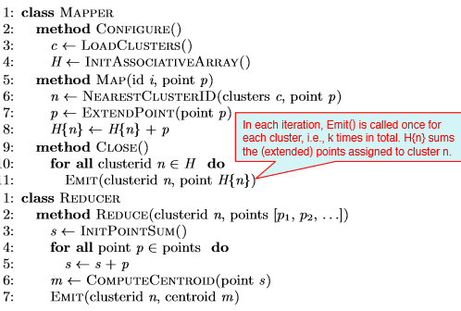

* **Total disk IO incurred:** O(kmd)

**Lecture 4 – NoSQL**

* NoSQL refers to non-relational databases that store data in formats other than relational tables
* It stands for "Not Only SQL," meaning it may include systems that use SQL-like querying languages and can be used alongside relational databases.

**Major Types of NoSQL Databases​​**

* Key-value stores (redis, DynamoDB)
* Wide column databases (Cassandra, HBase)
* Vector databases (Milvus, redis)
* Document stores (mongo, couchDB)
* Graph databases (Neo4j)

**Why NoSQL**

* Massive growth in web application data which are largely unstructured
* It can capture the growing volume, velocity and variety of data nowadays

**Brief overview of NoSQL systems**

* NoSQL databases are often **horizontally scalable**, which means they can handle more data by adding more servers to the network.
* They typically **replicate and distribute data over many servers** to handle larger volumes of data and provide high availability.
* NoSQL systems usually have **a simple call interface** for data operations
* Often a **weaker concurrency mode**l than traditional RDBMS.
* These systems are designed to **use distributed indexes and RAM efficiently.**
* NoSQL databases tend to have **flexible schemas** that can handle a variety of data types, which is particularly useful for applications dealing with large amounts of diverse data

**Key-Value Stores​​**

* Store associations between keys and values.
* Keys are usually primitive data types and can be queried.
  + e.g., integers, strings, raw bytes, etc.
* Values can be primitive or complex but usually cannot be queried
  + e.g., integers, strings, lists, JSON, HTML fragments, BLOBs (basic large objects), etc.
* **Key-Value Stores: Operations**
  + The API for key-value stores is very simple, typically including:
    - Get: Fetch the value associated with a key.
    - Put: Set the value associated with a key.
  + Optional operations might include multi-get, multi-put, and range queries.
  + Suitable for
    - small continuous read and writes,
    - storing basic information or data without a clear schema, and
    - situations where **complex queries are not or rarely required.**
  + Example applications include storing user sessions, caches, and user data that is often processed individually, such as patient medical data
* **Key-Value Stores: Implementation**
  + **Non-persistent**: Functions as a large **in-memory** hash table (e.g., Memcached, Redis). These systems can also periodically back up data to disk. Often very fast.
  + **Persistent**: Data is stored persistently on the disk. Examples include RocksDB, Dynamo, and Riak​. Comes with greater latency.

**Document Stores**

* Document stores manage data in a format that involves **collections of documents**.
* Each database can contain multiple collections, and each collection can have multiple documents.
* Documents in these stores are JSON-like objects with fields and values.
  + Different documents can have different fields, and
  + The fields can be nested (i.e., JSON objects as values)​

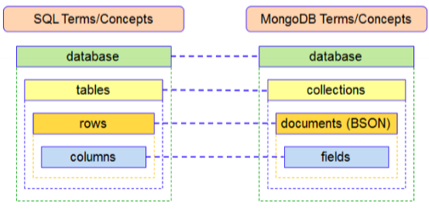

* **Document Stores: Querying**
  + Document stores offer querying capabilities based on the content of a document, unlike basic key-value stores which do not allow querying on the value.
  + The CRUD operations (Create, Read, Update, Delete) are fundamental to the querying capabilities in document stores. This allows for more complex interactions with the data compared to key-value stores

**Wide Column Stores**

* **Rows Describe Entities**: In wide column stores, rows are used to describe entities.
* **Column Families**: Related groups of columns are organized into column families.
  + Somewhat analogous to tables but not really
* **Sparsity**: These stores are efficient in terms of space usage. If a column is not used for a row, it doesn’t occupy space.
* **Examples**: Some well-known examples of wide column stores include BigTable, Cassandra, and HBase.

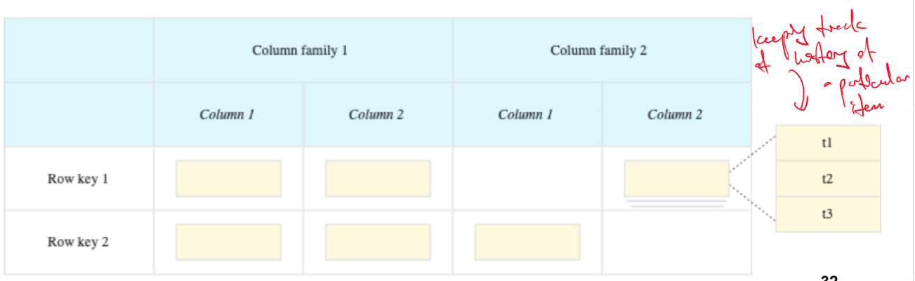

**Graph Databases**

* Stores information about each vertex and edge

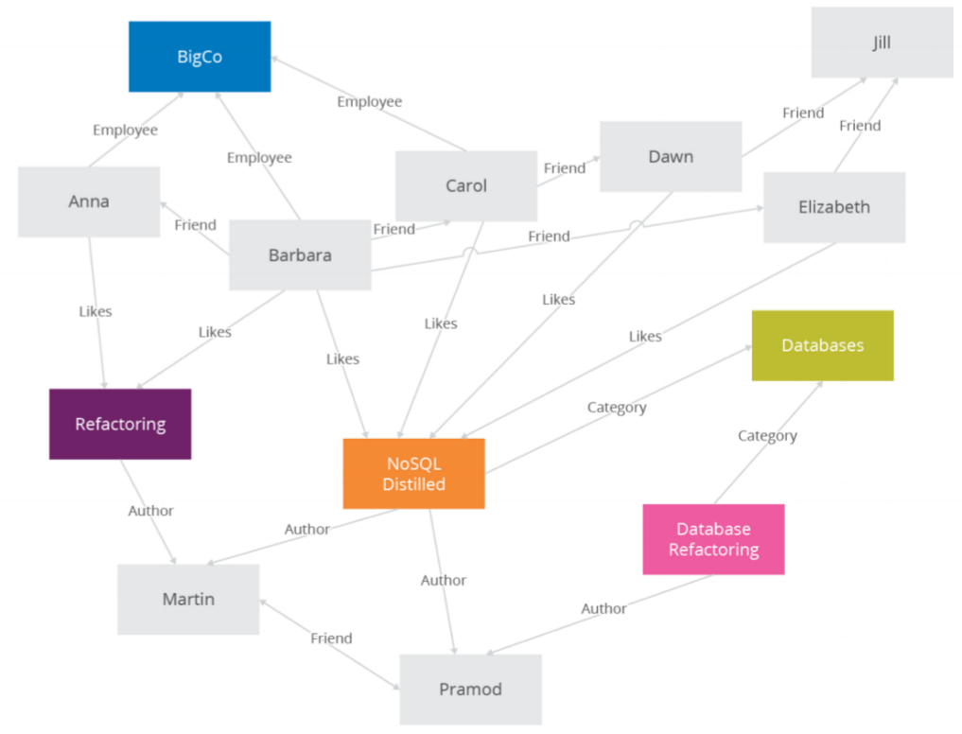

**Vector Databases**

* **Storing Vectors** – where each row represents a point in a multidimensional space.
  + Usually dense, numerical, and high dimensional
* Allows for fast similarity searches. For example, given a query, they can quickly retrieve similar neighbors from the database.
* Common DB characteristics: scalability, replication, real-time update
* Examples: Milvus, Redis, Weaviate, MongoDB Atlas
* **Vector Databases in AI/ML and Similarity Search**
  + Vector databases have gained prominence recently due to their applications in Artificial Intelligence (AI) and Machine Learning (ML).
  + They are particularly useful for handling operations related to large language models and vision models.
    - Example LLMs often convert text into vectors (or embeddings) useful for applications like search, recommendation, clustering
    - Similarly, vision models convert images into embeddings
  + To quickly search for similar embeddings (for example in search / recommendation), efficient and scalable vector DBs are needed

**Strong Consistency**

* Strong consistency means that any reads immediately after an update must return the same result across all observers.
  + All users block until the writes have been replicated across all nodes
    - Results in **reduced availability**
  + This ensures that all users see the same data at the same time.
* Strong consistency is crucial in systems where it's essential to read the most recent write, such as in financial transactions.

**Eventual Consistency**

* Eventual consistency means that if the system is functioning and given enough time, eventually all reads will return the last written value.
  + However, this implies that immediately after an update, different users might see different data.
  + i.e. stale data
* Eventual consistency offers **better availability** but at the cost of a weaker consistency guarantee.
  + This may be acceptable for applications like social network feeds or statistical queries, but not suitable for applications where immediate consistency is critical.
* **Tunable Consistency**: Many modern NoSQL systems allow for configurable consistency levels, including strong consistency. This concept is known as 'tunable consistency', providing flexibility to choose the level of consistency based on the application's requirements
* **Relational Databases (ACID):** Traditional relational databases provide stronger consistency guarantees, often adhering to the ACID principles
  + (Atomicity, Consistency, Isolation, Durability).
* **NoSQL Databases (BASE)**: Many NoSQL systems, on the other hand, relax these strict consistency requirements to a weaker approach known as BASE
  + (Basically Available, Soft State, Eventual Consistency).
  + This approach prioritizes availability and partition tolerance over strict consistency.

**Duplication (Denormalization)**

* **Context**: Duplication in NoSQL systems is often discussed in relation to joins, which are a staple feature in Relational Database Management Systems (RDBMS).
* **Strategy**: In scenarios where a database needs to display interconnected data (for example, posts with usernames), one approach is to duplicate certain data elements. This duplication is referred to as 'denormalization.'

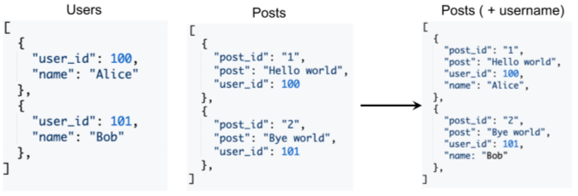

* **NoSQL Approach**: While some NoSQL databases do support joins (like later versions of MongoDB), another common approach in these systems is to duplicate data. This involves storing the same data in more than one place to reduce the need for complex joins and improve read performance.
* **Example**: In a social media context, instead of having separate 'Users' and 'Posts' tables and joining them to display posts with usernames, a NoSQL approach might involve storing the username directly with each post, duplicating the username information.

**Lecture 5 – NoSQL and Distributed Databases**

Focus on how NoSQL systems are implemented as distributed databases

**Rationale for distributed databases:**

* Scalability – to store more things
* Availability and fault tolerance – other DBs can step in if one dies
* Latency – Distributed databases allow users to choose the geographically closest replica

**Data Transparency**

* We provide abstraction to user for querying the database
* How data is physically distributed, partitioned or replicated is transparent to user

**Assumptions**

* All nodes in a distributed database are well-behaved (i.e. not adversarial)
  + Out of syllabus: Byzantine fault tolerant

**Types of distributed database architectures:**

* Monolithic – shared nothing
* Shared memory
* Shared disk
* Shared nothing – communicates processor results instead

**Partitioning Schemes:**

**Table Partitioning**

* Put different tables/collections on different machines
* Problem: Scalability is an issue if we want to expand the size of one table to store more items

**Horizontal Partitioning**

* Different Tuples are stored in different nodes
* Also called sharding
* Horizontal partitioning is generally bad if an operation requires access to tuples spread out across many partitions
  + **The task will need to be sent to all relevant partitions and might incur network I/O**
* Also bad for scalability if it causes allocation of tuples across partitions to be imbalanced
  + Might lead to **task straggler issue** if one task is running on a larger partition
  + **Bottleneck** issue if we are only writing to one partition at any one time
* Bad for scalability if the partitioning scheme causes tuples to be spread across too many partitions (sparsity) since it will be underscaled

Various sharding schemes:

* **Partition by key**
  + Each partition stores only the tuples that contain some key
  + Keys can be chosen based on the column that we group by/filter by most often
* **Range Partition**
  + Each partition stores tuples with a range of keys
* **Hash partitioning**
  + Uses a hash function to determine which key goes into which partition
  + How to ensure that we do not completely redo the partition if we add/remove a node? 🡪 consistent hashing

**Consistent Hashing**

* Outputs of the hash function is ordered around a circle
* Nodes are placed on the circle, essentially partitioning the circle.
* Moving in a clockwise manner around the circle, all the hashed keys are assigned to the next node on the circle.
* **Adding a New Node**: When a new node is added, it's placed into the ring. Only the keys that reside in the segment of the ring between the new node and its next clockwise neighbor need to be moved to the new node.
* **Removing a Node**: When a node is removed, its keys are moved to the next node clockwise on the ring. This means that only a small number of keys need to be moved when nodes are added or removed, providing a degree of stability
* **Simple Replication Strategy**:Store the tuples with keys in the first node encountered clockwise, then replicate the tuples in the next node encountered clockwise
* **Replication for Load Balancing:** To balance the load more evenly, each node is replicated several times around the hash ring. These replicas are called "virtual nodes." Each virtual node is treated as a separate node in the hashing process, though they map back to the same physical server.

**Query Processing in NoSQL databases (using MongoDB as case study)**

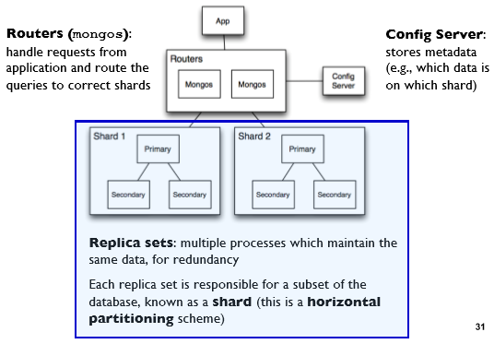

* Query is issued to a router instance
* With the help of config server, the router determines which shards to query
* Query is only sent to relevant shards
* Shards run query on their data and send results back to the router
* Router merges query results and returns merged result to application

**MongoDB Replication**

Each shard has a common replication configuration of 1 primary and 2 secondaries

* **Primary**
  + Receives all write operations
  + Records the write operations into operation log
  + Secondaries will replicate and apply the operation log to their local copies (thereby synchronizing their data), then acknowledge the operation
* **Secondary**
  + User can configure the read preference, which determines whether to read from the secondaries (default option) or the primary
  + Allowing reading from secondary can reduce latency and distribute load depending on where the secondary is located, but allows for reading of stale data (eventual consistency)
* **Elections**
  + If the primary node fails, the nodes “conduct an election” to choose which of the secondary nodes to be promoted

**Lecture 6 – Spark I**

**Motivation: Issues with Hadoop MapReduce**

* **Network and Disk I/O costs:** Intermediate data is emitted and written to local disk and shuffle across machines, which incurs I/O costs
  + Each iterative step is modeled as a map-reduce job
* **Spark** stores most of its intermediate results in memory, making it much faster, especially for iterative processing
  + **When memory is insufficient**, Spark spills to disk which incurs disk I/O (demand paging)

**Ease of Programmability**: Spark provides simpler coding for complex operations compared to Hadoop.

**Spark Components and Architecture**

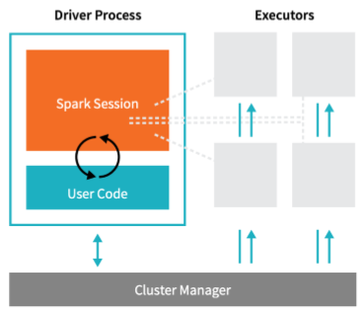

**Driver Process:** Manages the Spark application and distributes work to Executors.

**Executors:** Run code assigned to them and send results back to the Driver.

**Cluster Manager:** Allocates resources (can be Spark's standalone manager, YARN, Mesos, or Kubernetes).

**Evolution of Spark APIs**

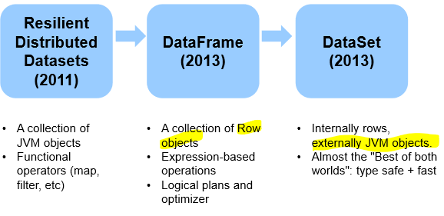

**Resilient Distributed Datasets**

RDDs are the fundamental data structure of Spark, representing a collection of elements partitioned across nodes.

**Immutability**: Once created, RDDs cannot be changed.

**Lazy Evaluation –** Transformations on RDDs are lazy, meaning they're not computed immediately but only when an action is called.

* **Transformations** – Lazily transforms a RDD into another RDD
  + E.g. of Transformation operations: **map, order, groupBy, filter, join, select**
* **Actions** – Triggers Spark to compute a result from a series of transformations
  + E.g. of Actions: **show, count, save, collect**

**Distributed Processing**

* RDDs are distributed across machines
* 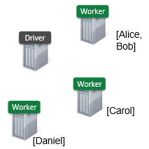Thus, the transformations and actions are executed in parallel, and the results are only sent to the driver in the final step.
  + Example – creating an RDD of names, distributed over 3 partitions:

dataRDD = sc.parallelize([“Alice”, “Bob”, “Carol”, “Daniel”], 3

**Persistence** – Users can persist (cache) RDDs in memory across operations, which is crucial for iterative algorithms like machine learning. Each worker keeps a cache of its partition

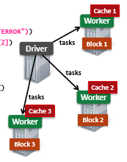🡪 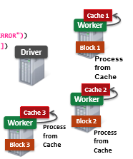

**Directed Acyclic Graphs**

* 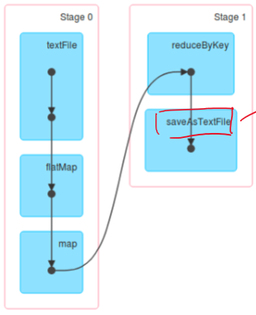Internally, Spark creates a DAG which represents all the RDD objects and how they will be transformed.
* Transformations construct this graph; actions trigger computations on it

In the DAG, consecutive narrow dependencies are grouped together as “stages”

**Narrow Dependencies** – Each partition of the parent RDD is used by at most 1 partition of the child RDD

* Typically transformations that only operate within the same partition/node
* Examples: map, flatMap, filter, contains

**Wide Dependencies** – Each partition of the parent RDD can be used by multiple partitions of the child RDD

* Involves shuffling data across partitions and writing intermediate results to disk
  + During cross-stage transformations, data is shuffled and combined into a new partition in the child RDD. The new partition will be written to the worker’s hard disk for fault tolerance purposes.
  + If a worker node goes down, this partition of the RDD exists in the worker’s disk, allowing it to recompute the stage.
* Also known as cross-stage transformations
* **Examples**: reduceByKey, groupBy, orderBy

**No Replication for Fault Tolerance**

Unlike traditional systems that use data replication for fault tolerance, Spark uses lineage for recovery.

* Spark tries to store all data in memory and not disk. Given that memory capacity is much more expensive than disk memory, replicating all data is expensive.

**Lineage Approach:** If a node fails, Spark reconstructs the lost data using the lineage graph (DAG) to recompute only the affected partitions, not the entire RDD

**DataFrames**

* DataFrames represent a table of data, similar to SQL tables or pandas DataFrame.
* Represents a higher-level abstraction than RDDs and has transformations that resemble SQL operations.
  + 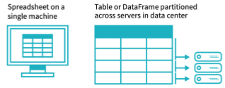DataFrames (and Datasets) are the recommended interface over RDDs. They are easier to use than RDD and almost all tasks can be done with them, while only rarely using RDD functions
  + While DataFrames offer a higher-level interface, under the hood, their operations are compiled down to RDD operations by Spark.

**Transforming DataFrames with SQL Queries**

* DataFrames can be transformed using SQL queries in Spark.
* First, a temporary view is created from a DataFrame, allowing SQL queries to be run against it.
* An example is shown where a query is executed to select the top 5 countries by the sum of a 'count' column, ordering the results in descending order.

|  |
| --- |
| flightData2015.createOrReplaceTempView("flight_data_2015")  maxSql = spark.sql("""  SELECT DEST_COUNTRY_NAME, sum(count) as destination_total  FROM flight_data_2015  GROUP BY DEST_COUNTRY_NAME  ORDER BY sum(count) DESC  LIMIT 5  """)  maxSql.collect() |

**Transforming DataFrames using DataFrame API**

* The same operations can be performed using the DataFrame API, which uses method chaining for transformations.
* The transformations in the DataFrame API can use either string literals or column objects to refer to column names.
* For instance, the 'desc' function returns a column object

|  |
| --- |
| from pyspark.sql.functions import desc  flightData2015\  .groupBy("DEST_COUNTRY_NAME")\  .sum("count")\  .withColumnRenamed("sum(count)", "destination_total")\  .sort(desc("destination_total"))\  .limit(5)\  .collect() |

**Datasets**

Datasets are similar to DataFrames and offer type safety, meaning that they are strongly typed and provide compile-time type checking.

* In fact, in Spark (Scala), DataFrame is just an alias for Dataset containing Row objects.
* Datasets are not available in Python and R because they are dynamically typed.

|  |
| --- |
| case class Flight(DEST_COUNTRY_NAME: String, ORIGIN_COUNTRY_NAME: String, count: BigInt)  val flightDF = spark.read.parquet("/mnt/defg/flight-data/parquet/2010-summary.parquet/")  val flights = flightDF.as[Flight]  flights.collect() |

* The Dataset flights is type-safe, and its type is the Flight class.
* When the collect() action is performed, it will return objects of the Flight class instead of generic Row objects.

**Lecture 7 – Spark II**

**Spark Design Philosophy**

* **Speed**
* **Ease of Use**
  + Allowing SQL-based commands
* **Modularity**
  + Separation of concerns into different Spark Modules
* **Extensibility**
  + Compatible with many database/storage solutions

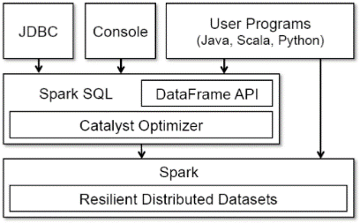**SPARK SQL**

* Provides a unified stack for distributed execution, allowing abstraction to DataFrames and Datasets in Java, Scala, Python, and R.
* Keeps track of the schema and supports optimized relational operations.

**RDD vs. DataFrame:**

* RDDs instruct Spark on how to compute the data
* Intention of user is opaque to Spark
* Spark doesn't understand the structure of the data in RDDs (which are arbitrary Python objects) or the semantics of user functions
* DataFrames tell Spark what to do rather than how to do it
  + Functional paradigm
* Uses high-level domain specific language operators to compose queries
  + similar to python pandas
* Spark can inspect/parse this query to understand the user intention and perform optimization/rearrangement for efficient execution

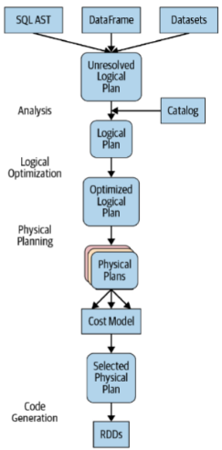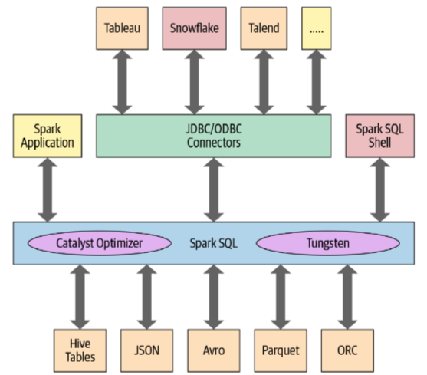

**Catalyst Optimizer**

* Takes computational queries and converts them into an execution plan through phases:
  + analysis,
  + logical optimization,
  + physical planning, and
  + code generation.
* This optimizer provides performance parity across languages.

**Machine Learning Pipeline**

A typical machine learning pipeline

* Data preprocessing 🡪 training 🡪 testing 🡪 evaluation

**Data Preprocessing and Quality**

* Poor data quality costs the typical company at least 10% of revenue; 20% is a better estimate
* Garbage in, Garbage Out

**Dealing with Missing Values**

Information might not be collected or missing at random – e.g. due to sensor issues

* If information is **not missing at random**, then the missing information may be indicative of important information
* We can eliminate rows with missing values, or
* Perform Imputation (such as based on mean/median) or fitting a regression model to predict that attribute.
* Use dummy variables – insert a column which is 1 if the variable was missing and 0 otherwise

**Categorical Encoding**

* We can convert ordinal categorical features into numerical features
  + E.g. [Low, Med, High] 🡪 [0,1,2]
* We can perform One Hot Encoding on non-ordinal categorical features
  + Use OneHotEncoder or RFormula for this

**Feature Scaling and Normalization**

For training on distance-based models, we might need to scale our numerical features

* Clipping, Log Transformation, Standard Scaler, Max-min Normalization

**Logistic Regression –Sigmoid Function**

$σ\left(x\right)=\frac{1}{1+e^{-x}}$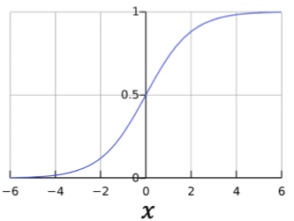

**Logistic Regression involves fitting the parameters of a model (in this case weights and bias) by minimizing a cost/loss function: $L_{train}(weights, bias)$**

**Evaluation metrics**

* FN – Wrongful positive identification (is it costly to accuse something?)
* FP – Missing out on positive identification (is it costly to miss something? )
* Accuracy = (TP+TN)/(TP+TN+FP+FN)
* Sensitivity = Fraction of Positive cases that are detected = TP/(TP+FN)
* Specificity = Fraction of Actual Negatives that are correctly identified = TN/(TN + FP)

**Implementing ML Pipeline using Spark MLlib**

**Transformers –** Maps a dataframe to another dataframe

* E.g. One-hot encoding, tokenization
* Has a transform() method, which performs its transformation
* Generally outputs a new DataFrame which append their results to the original DataFrame
  + i.e. a new column will be added
* A fitted model is a Transformer that transforms a DataFrame into one with predictions appended

**Estimator** – an algorithm which takes in data and outputs a fitted model.

* Has a fit() method, which returns a Transformer

**Pipelines** – building complex pipeline out of simple building blocks (e.g. encoder, normalizer, feature transformer, model fitting)

* Allows for better code reuse
* Easier to perform cross validation and hyperparameter tuning
* A pipeline chains together multiple Transfortmers and Estimators to form a ML workflow
  + If a Pipeline contains an Estimator, it is an estimator and requires Pipeline.fit() to be called to fit the estimators in the pipeline.
    - transform() method of each transformer in the pipeline is called
    - fit() method of each estimator in the pipeline is called to return a fitted model
  + The output of pipeline.fit() is the fitted pipeline model containing the fitted models in the pipeline
    - When transform() is called, each stage’s transform() method is called

**Evaluating Regression Models**

* **Mean Absolute Error (MAE): $MAE=\frac{1}{n}\sum_{i=1}^{n}{\left| y_{i}- \hat{y_{i}}\right|}$** 
  + The MAE measures the average magnitude of the errors between the predicted values and the actual values, without considering their direction.
* **Mean Squared Error (MSE): $MSE=\frac{1}{n}\sum_{i=1}^{n}{{\left(y_{i}-\hat{y_{i}}\right)}^{2}}$** 
  + The MSE measures the average of the squares of the errors—that is, the average squared difference between the estimated values and the actual value.
* **Root Mean Squared Error (RMSE): $RMSE=\sqrt{\frac{1}{n}\sum_{i=1}^{n}{{\left(y_{i}-\hat{y_{i}}\right)}^{2}}}$**
  + The RMSE is the square root of the average of squared differences between prediction and actual observation. It is a measure of the magnitude of errors between pairs of observations.

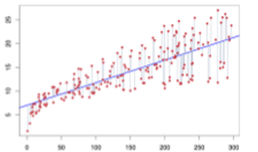

* **R Squared Value (R²)**
  + It indicates the proportion of the variance in the dependent variable that is predictable from the independent variables.
  + The closer the R² value is to 1, the better the model fits the data.
  + The R² value is a dimensionless number between 0 and 1, and a model with an R² value closer to 1 is typically considered to have a better fit to the observed data.
  + R² is calculated as: $R^{2}=1-\frac{SS_{res}}{SS_{tot}}$
    - where $SS_{res}$ is the sum of squares of the residual errors, calculated as

* + - is the total sum of squares, which measures the total variance in the dependent variable, calculated as: $SS_{tot}=\sum_{i}{{\left(y_{i}-\overline{y}\right)}^{2}}$
    - Where $\overline{y}$  is the mean of the observed data $\overline{y}=\frac{1}{n}\sum_{i=1}^{n}{y_{i}}$

**Lecture 8 – Streams**

* **Streaming Data:** In many real-world scenarios, data does not arrive all at once but continuously over time.
* Streaming (or "online") data processing approaches are designed to handle data as it arrives, processing the input incrementally rather than waiting for the entire dataset to be available.
  + Stream Processing offers responsiveness since the stream input is processed immediately
  + Offline/Batch processing requires the input to be batched first before it can be processed

**Spark: Micro-Batch Streaming Processing**

* Spark Structured Streaming uses a micro-batch processing model
* Divides the data from input stream into micro-batches
* Each batch is processed in the Spark Cluster in a distributed manner
* Small deterministic tasks generate the output in micro-batches
* **Incremental Execution**: Each micro-batch is executed incrementally, updating the final result with data from the new batch.
  + New rows from each batch are appended to an unbounded table

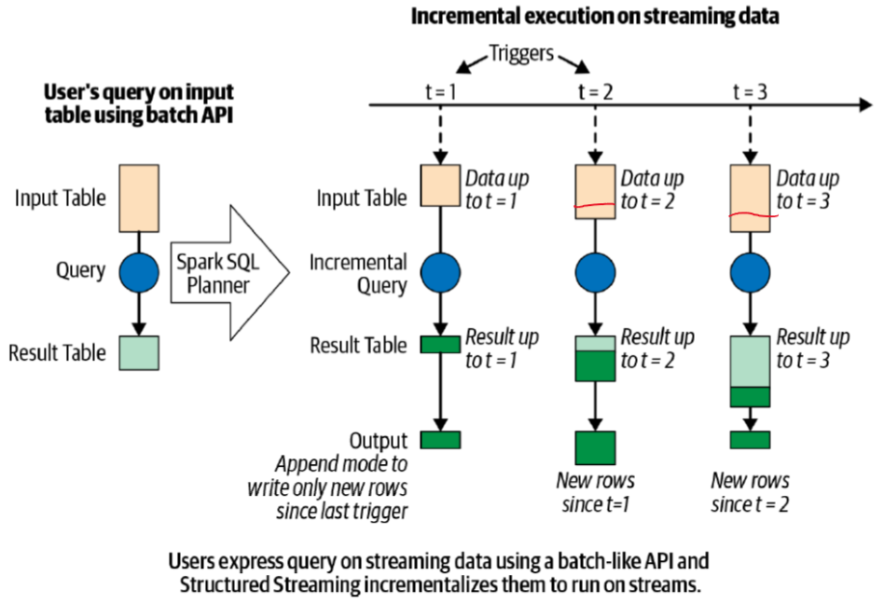

**Advantages:**

* Quickly and efficiently recover from failures
* Deterministic nature ensures end-to-end exactly-once processing guarantees

**Disadvantages:**

* Latency of a few seconds

**Writing Structured Streaming Queries**

For developers, writing stream processing pipelines should be as easy as writing batch pipelines

* Same API/programming model and interface for batch and stream processing
  + Should work on both tables and data stream
  + Structured Streaming Programming model simply defines a data stream as an unbounded table

**Steps:**

* Define input sources
* Transform data.
* Define output sink and output mode.
  + e.g. where to write and how to write (append mode or return complete table)
* Specify processing details, including triggering, and checkpointing.
  + How to process data and how to recover from failures
  + Triggering details – when to trigger the discovery and processing of newly available stream data (e.g. micro-batches of 5 mins? Etc…)
  + Checkpointing Location – where to store the streaming query process information for failure recovering
* Start the query.

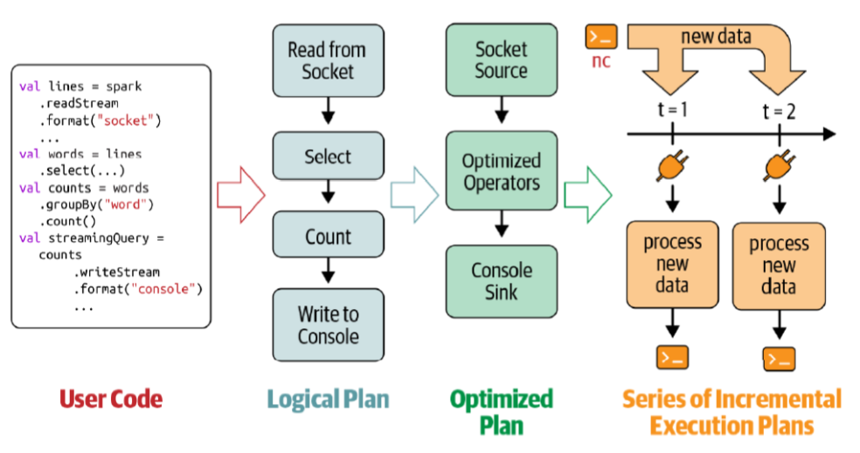

**Data Transformation**

**Stateless Transformation**

**-** Process each row individually without needing any information from previous rows

- e.g. Projection Operations – select(), explode(), map(), flatMap()

- Selection Operations: filter(), where()

**Stateful Transformation**

* Requires information from previous rows (i.e. old streaming data)
* Using DataFrame.groupBy().count() as example, in every micro-batch, the incremental plan adds the count of new records to the previous count generated by the previous micro-batch
* The partial count communicated between plans is the state
  + The state is maintained in the memory of the Spark Executors and is checkpointed to the configured location to tolerate failures

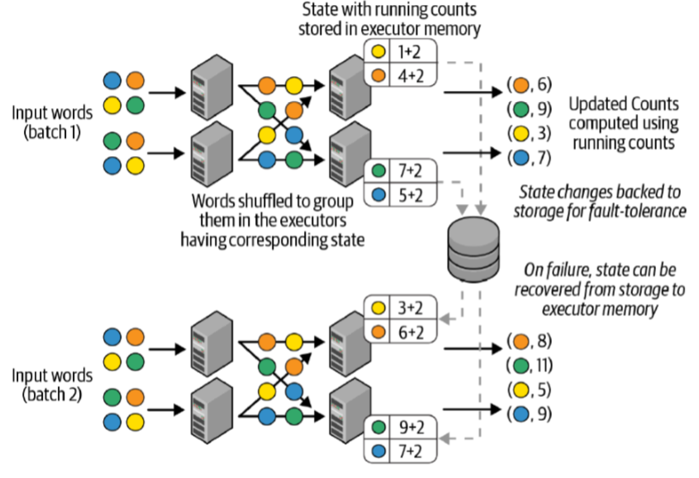

* **Stateful Transformation Aggregations not based on time**
  + Global Aggregations
    - runningCount = sensorReadings.groupBy().count()
  + Grouped Aggregations
    - baselineValues = sensorReadings.groupBy(“sensorId”).mean(“value”)
  + All built-in aggregation functions in Dataframes are supported
    - sum(), mean(), stddev(), countDistinct(), collect_set(), approx._count_distinct(), etc.
* **Stateful Transformation Aggregations based on time**
  + Aggregation with Event-Time Windows
    - sensorReadings.groupBy(

“sensorId”, window(“eventTime”, “5 minute”)).count()

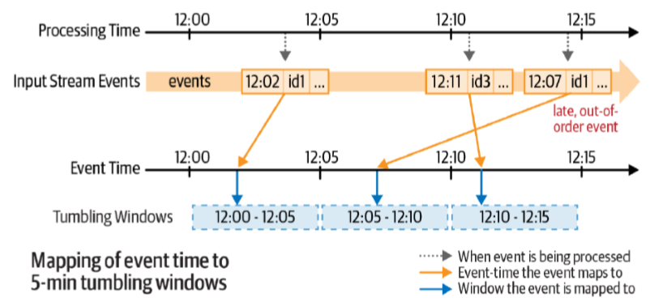

* + - sensorReadings.groupBy(

“sensorId”, window(“eventTime”, “10 minute”, “5 minute”)).count()

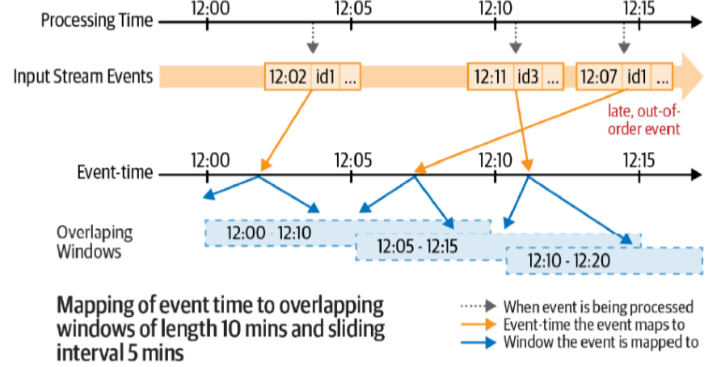

* + Updated counts in the result table after each 5-minute trigger

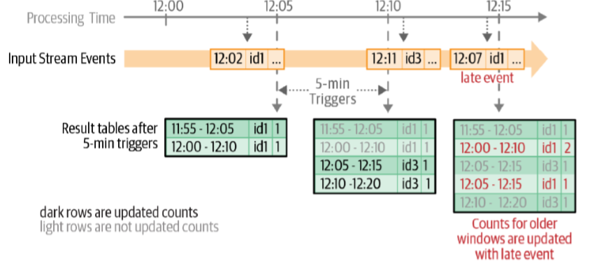

* + Handling Late Data with Watermarks
    - sensorReadings

.withWatermark(“eventTime”, “10 minutes”)

.groupBy(“sensorId”, window(“eventTime”, “10 minutes”, “5 minutes”))

.count()

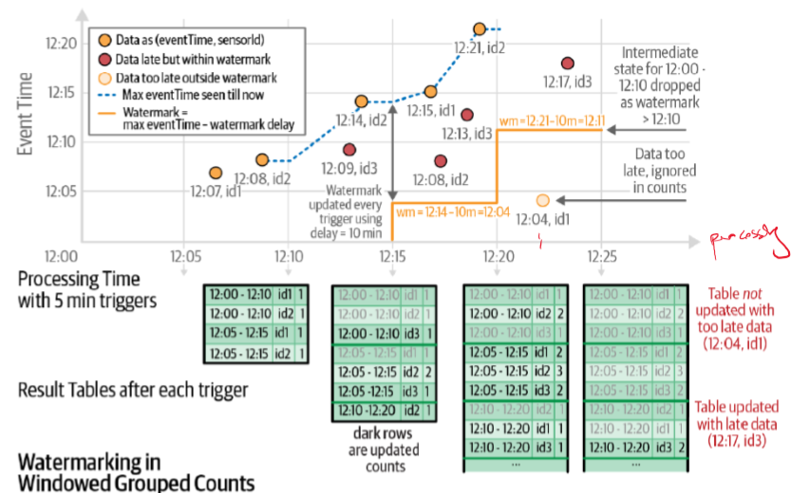

**Time Semantics**

Processing Time – The time of the stream processing machine

Event Time – The time that the event actually happened (usually captured through timestamping)

* Event Time completely decouples the processing speed from the results
* Operations based on event time are predictable and results are deterministic
* An event time window computation will yield the same result no matter how fast the stream is processed or when the events arrive at the operator

**Performance Tuning**

* Besides tuning Spark SQL engine, a few other considerations
  + Cluster resource provisioning appropriately to run 24/7
  + Set number of partitions to be much lower than in batch processing to reduce network I/O latency
  + Setting source rate limits for stability 🡪 unstable if arrival rate > service rate
  + Multiple streaming queries in the same Spark application

**Flink**

* **Does not perform micro-batch processing**
* **Stream native processor**

**Real-Time Processing**

* Stream native processor -> millisecond latency achievable
* Flink processes streams in real-time, with a latency in the order of milliseconds, as opposed to the seconds-scale latency of Spark's micro-batch processing.

**Dataflow Model**

* Logical Dataflow Graph

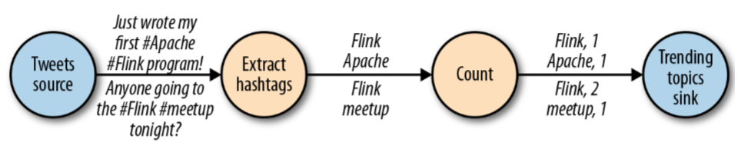

* Physical Dataflow Plan

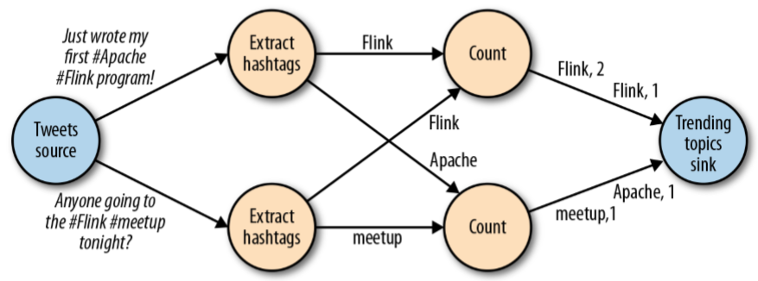

* Data exchange strategies

|  |  |
| --- | --- |
|  |  |
|  |  |

**Stateful Parallel Data Stream Processing**

* Flink is designed as a distributed system capable of stateful parallel data stream processing.

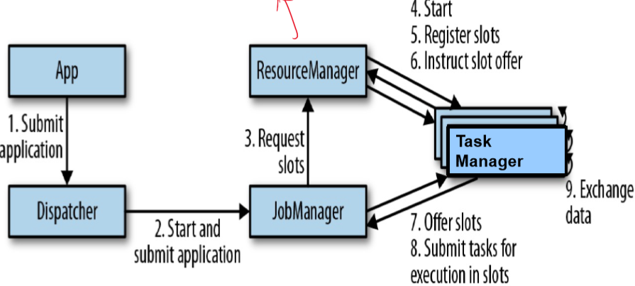

* A Task Manager can execute several tasks at the same time to achieve parallelism
  + Tasks of the same operator (data parallelism)
  + Tasks of different operators (task parallelism)
  + Tasks from a different application (job parallelism)

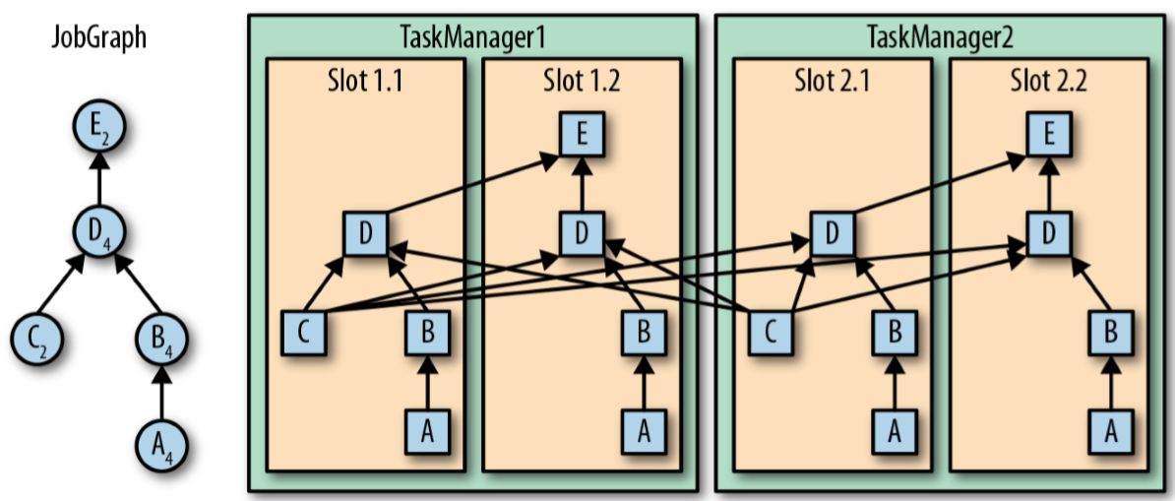

* A Task Manager offers a certain number of processing slots to control the number of tasks it is able to concurrently execute
* A processing slot can execute one slice of an application – one parallel task of each operator of the application

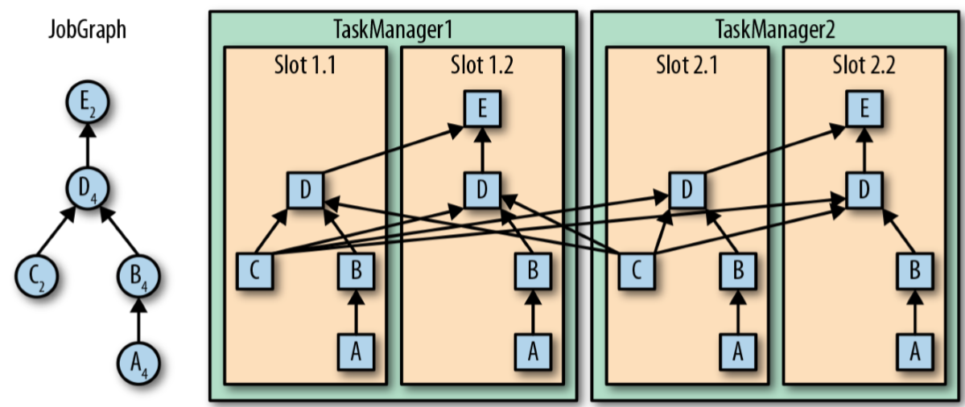

* The tasks of a running application are continuously exchanging data
* The TaskManagers take care of shipping data from sending tasks to receiving tasks
* The network component of a TaskManager collects records in buffers before they are shipped

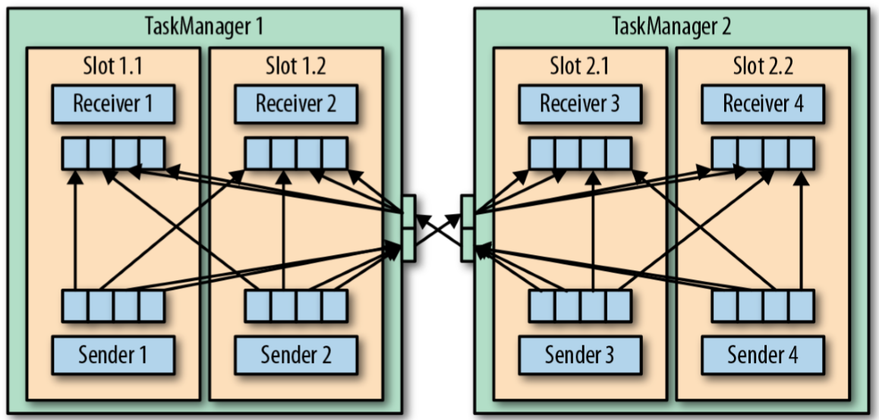

**Event Time Processing with Watermarks**

* Every record must be accompanied by an event timestamp
* Flink handles event time processing by incorporating watermarks, which allow the system to manage the timing of events and handle late data.
  + Watermarks are implemented as special records holding a timestamp as a Long value. Watermarks flow in a stream of regular records with annotated timestamps.
  + For example, a watermark with timestamp 5 implies that all records after the watermark with a timestamp less than 5 means it is late.

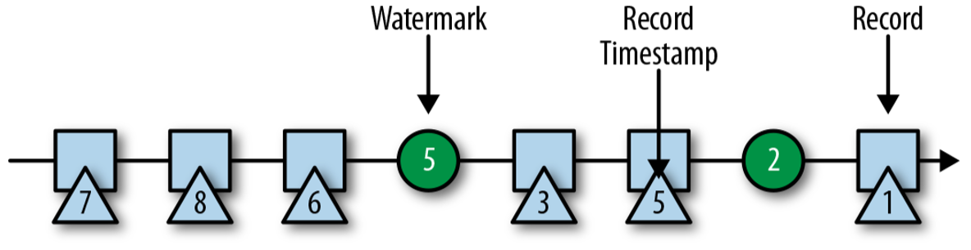

**State Management:**

* Flink employs distributed snapshots for state management, using checkpoint barriers to maintain state across distributed systems.

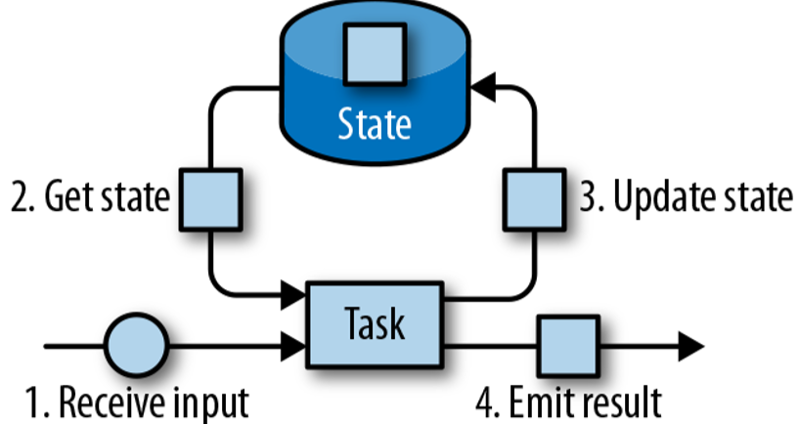

* 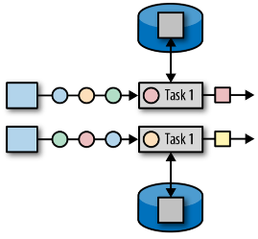**Operator State**
  + Scoped to an operator task
  + All records processed by the same parallel task have access to the same state
  + Operator State cannot be accessed by another task of the same or different operator
* **Keyed State**
  + Maintains one state instance per key value
  + Partitions all records with the same key to the operator task that maintains the state for this key

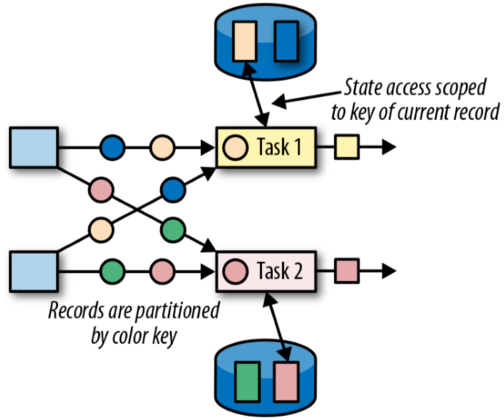

**State Backend:**

* **Local State Management**
  + A task of a stateful operator typically reads and updates its state for each incoming record
  + Each parallel task locally maintains its state in memory to ensure fast state accesses
* **Checkpointing**
  + A TaskManager Process may fail at any point, hence its storage must be considered volatile
  + Checkpointing the state of a task to a remote and persistent storage
  + The remote storage for checkpointing could be a distributed filesystem or database system

**Efficient Checkpointing:**

* Unlike Spark's synchronous checkpointing for each micro-batch ("stop the world"), Flink performs checkpointing in a distributed and asynchronous manner, leading to more efficient processing and lower latency.
* **Consistent Checkpointing (similar to Spark micro-batch checkpoints)**
  + Pause ingestion of all input streams
  + Wait for inflight data to be completely processed
  + Take a checkpoint by copying the state of each task to remote, persistent storage. The checkpoint is complete when all tasks finish their copies
  + Resume the ingestion of streams

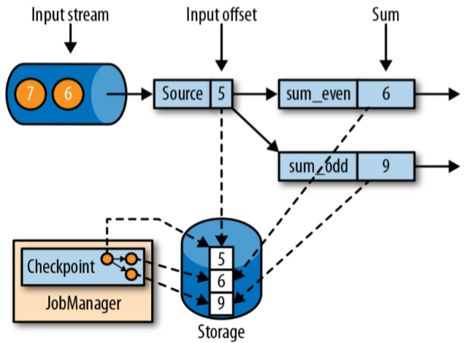

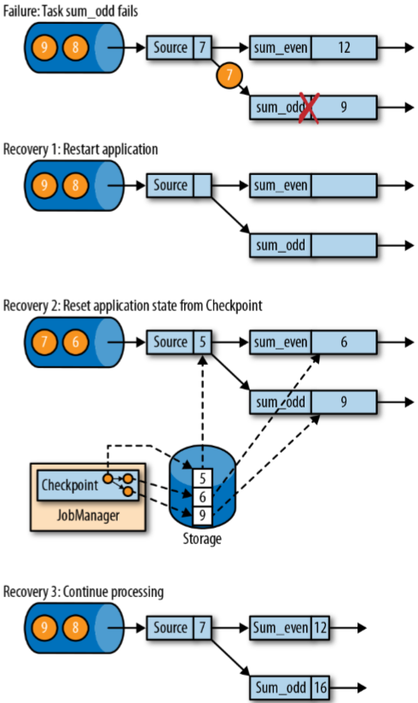

* **Flink’s Checkpointing Algorithm**
  + Does not pause the entire application but decouples checkpointing from processing
  + Some tasks continue processing while others persist their state
  + Uses a special record called a checkpoint barrier
  + Checkpoint barriers are injected by source operators into the regular stream of records and cannot overtake or be passed by other records
  + A checkpoint barrier carries a checkpoint ID to identify the checkpoint it belongs to and logically splits a stream into two parts
  + All state modifications due to records that precede a barrier are included in the barrier’s checkpoint and all modifications from records that follow the barrier are included in a later checkpoint

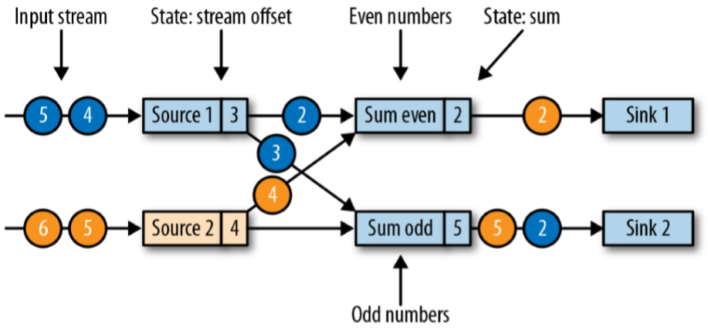

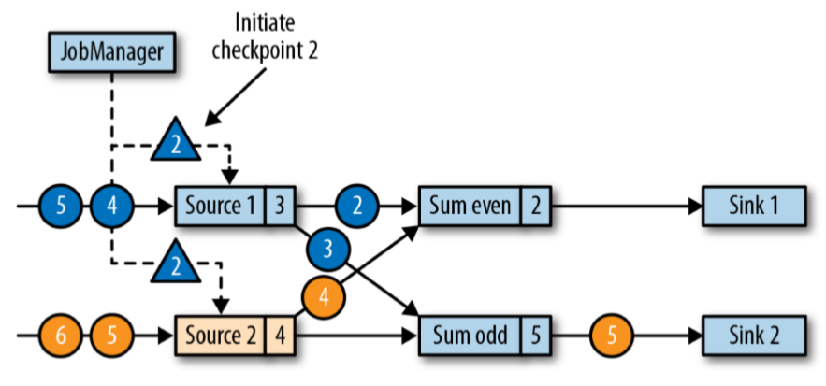

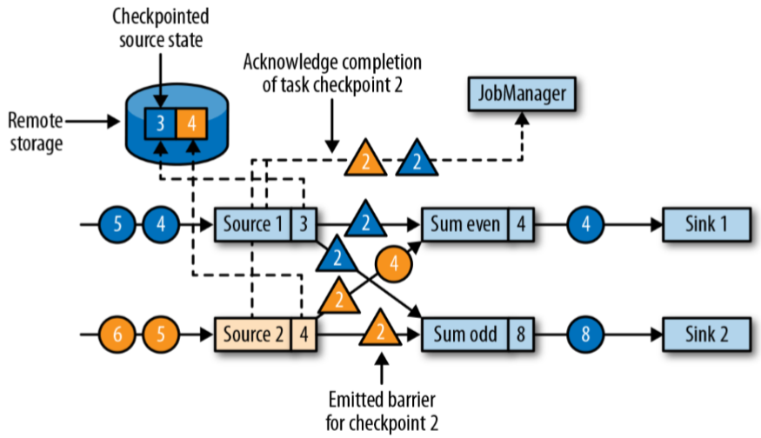

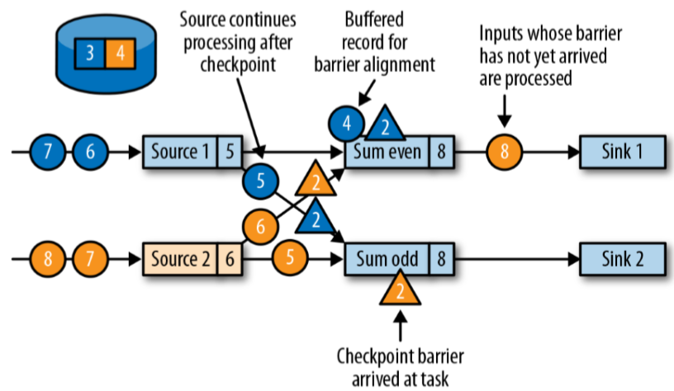

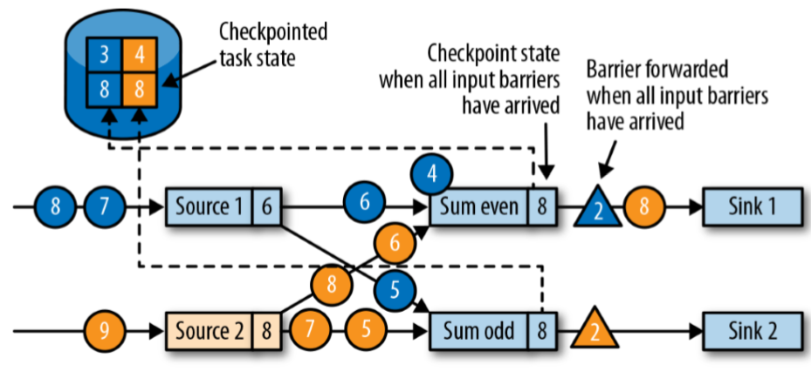

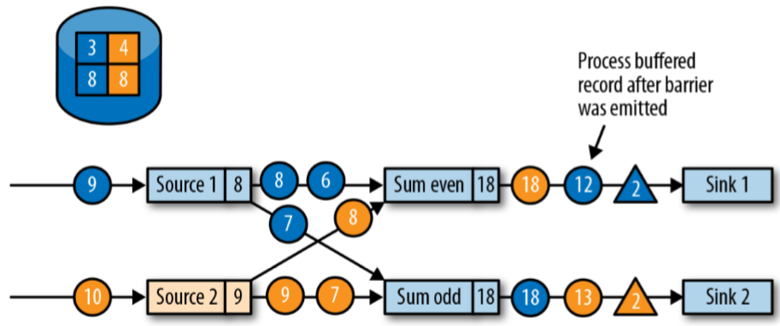

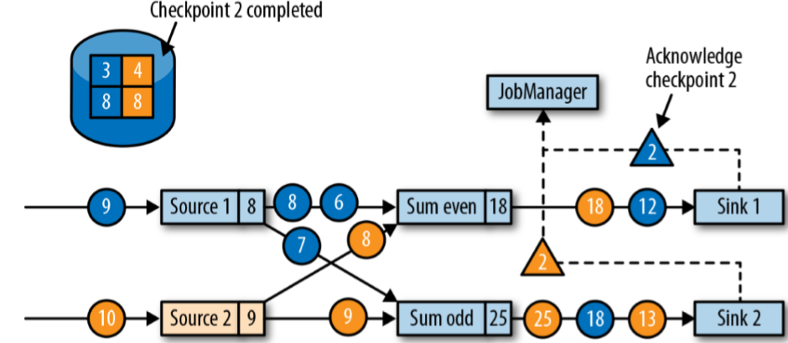

**Handling Late Events:**

* Flink uses late handling functions related to watermarks to determine when to drop late-arriving events

**Lecture 9 – Graphs**

**Simplified PageRank**

All pages on the internet can be ranked based on their ‘importance’. The PageRank algorithm considers incoming links into a webpage (vertex) to contribute to a page’s importance. The importance contributed by an incoming link from a page is weighted by the page’s importance

* PageRank assumes that votes (links) from important pages are more significant.
* Importance (rank) of a page $j$, denoted $r_{j}$, is defined as the sum of the importance of pages linking to it, each divided by their number of out-links $d_{i}$
* Flow equations for a simplified model are given by:
$$r_{j}=\sum_{i→j}{\frac{r_{i}}{d_{i}}}$$

* Additionally, a constraint of $\sum_{i}{r_{i}}=1$ forces uniqueness for the solution

**Matrix Formulation for Simplified PageRank**

* The stochastic adjacency matrix $M$ has columns summing to 1.
  + If page $i$ has $d_{i}$ out-links, and
  + $i→j$, then $M_{ji}=\frac{1}{d_{i}}$,else $M_{ji}=0$
* The rank vector $r$ contains the importance score for each page/vertex
  + $r_{i}$ is the importance score for page $i$
$\sum_{i}{r_{i}}=1$

* The matrix formulation is given by

$r=M∙r$

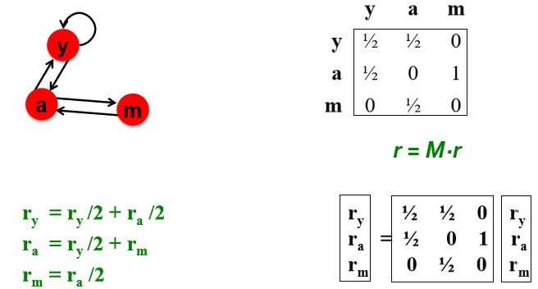

* **Power Iteration Method to compute $r$** 
  + Initialize $r^{(0)}$ with equal importance for each node ($\frac{1}{N}$)
  + Iterate $r^{(t+1)}=M∙r^{(t)}$
    - i.e. $r_{j}^{(t+1)}=\sum_{i→j}{\frac{r_{i}^{\left(t\right)}}{d_{i}}}$
  + Stop when the change in rank vector between iterations is less than a threshold $ϵ$
 $\left|r^{\left(t+1\right)}-r^{\left(t\right)}\right|<ϵ$

   - The L1 norm is used to measure the change, which can be replaced by other norms like Euclidean norm for convergence testing
* During each iteration step, each node passes its current importance along its outgoing edges to its neighbors

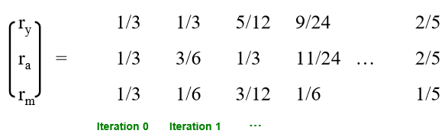

* **Random Walk Interpretation**

Imagine a random web surfer

* + At time $t=0$, surfer starts on a random page
  + At each timestep $t$, the surfer follows an out-link from their current page uniformly at random
  + Process is repeated indefinitely, with the probability that the surfer is at a given page at time $t$ represented by a vector $p(t)$
  + The location of the surfer at time $t+1$ is determined by following a link uniformly at random: $p(t+1)=M⋅p(t)$
    - If the random walk reaches a stationary state $s$, then $s=M⋅s$
    - This stationary state is equivalent to the rank vector $r$ in the 'flow' formulation of PageRank: $r=M⋅r$
    - Thus, the recursive definitions of the random walk and the flow formulations are the same

**Problems with Simplified PageRank**

* **Non-convergence**
  + PageRank might not converge. For example,

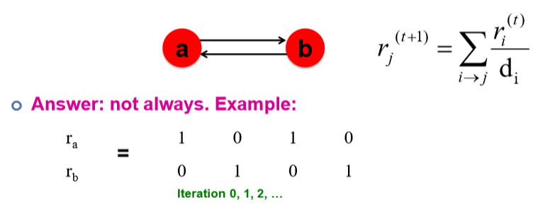

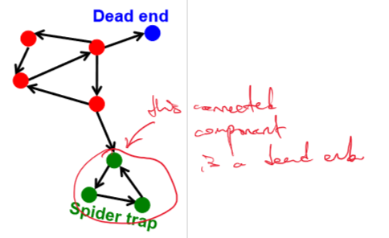

* **Dead ends**
  + Pages with no out-links can cause the PageRank to "leak" out of the system, as there are no pages to distribute the rank to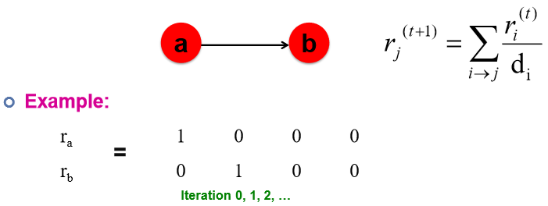
  + In the matrix formulation, we can see that the column for vertex m is not stochastic
  + 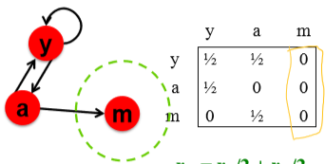
* **Spider Traps**
  + A set of pages where all out-links point within the group, can lead to those pages accumulating all importance and not distributing it back to the rest of the web.

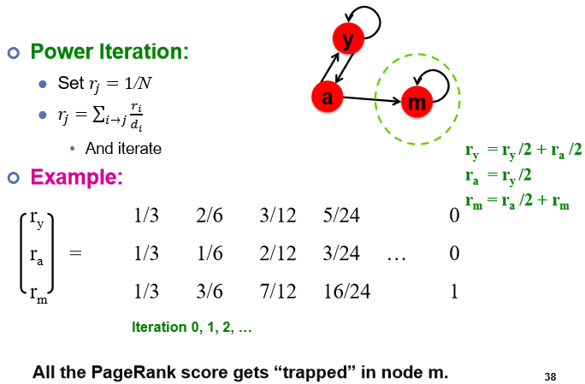

**PageRank with Teleports**

* Teleports are used to address both dead ends and spider traps.
  + Never get stuck in spider trap by teleporting out of it in a finite number of steps
  + Dead end never leaks ‘importance’ by teleporting out with probability 1 and hence making column stochastic
* With probability $1-β$, they allow the random surfer to jump to a random page (including itself), rather than following an out-link, ensuring that the importance can be redistributed across the entire network.
* For dead ends, probability of a teleport is 1 rather than $1-β$
  + i.e. always teleport
  + Thus, this makes the column for the dead end stochastic.

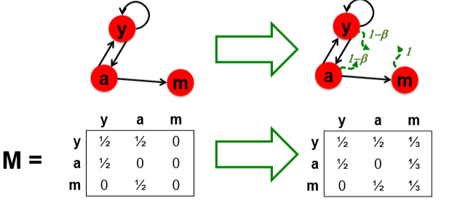

* PageRank Equation
$$r_{j}=\sum_{i→j}{β\frac{r_{i}}{d_{i}}+\left(1-β\right)\frac{1}{N} }$$

* Matrix formulation (The Google Matrix)
 $$A=βM+\left(1-β\right){\left[\frac{1}{N}\right]}_{N×N}$$

 + where $M$ is the stochastic adjacency matrix, β is the damping factor, and [1/N] is the matrix with all entries equal to 1/N

**Problems with PageRank**

* **Generic Popularity**
  + PageRank traditionally measures the generic popularity of a page, which may not be relevant to specific topics of interest to users.
  + Solution: Topic-Specific PageRank is introduced to measure popularity based on specific topics, providing a more tailored ranking.
* Single Measure of Importance:
  + The original PageRank algorithm uses a single measure of importance for ranking pages.
  + Solution: Alternative models, such as Hubs-and-Authorities (HITS algorithm), provide different ways to consider the importance of web pages.
* Susceptibility to Link Spam:
  + PageRank can be manipulated by artificially creating link topographies designed to boost the rank of certain pages.
    - PageRank implementation with Power Iteration does not solve this since we start all pages with equal importance
  + Solution: TrustRank helps to combat link spam by differentiating between trustworthy and spammy pages and penalizing the latter.

**Topic Specific PageRank**

* Rank the importance of web pages based on their closeness to a particular topic
* **Teleportation**: The random walker (or surfer) has a small chance of teleporting at any step.
  + **Standard PageRank**: Teleportation is to any page with equal probability
  + **Topic-Specific PageRank**: Teleportation is to a set of pages $S$ that are relevant to a specific topic.
* The teleportation part of the PageRank formula is updated to account for the topic-specific teleport set $S$.
  + Teleport Set $S$: Contains pages relevant to the topic, like those categorized under a certain topic in the Open Directory (DMOZ).
    - In standard PageRank, the teleport set is all the vertices in the graph
  + For every different teleport set, the PageRank vector $r_{s}$ is computed differently.
  + Pages in the teleport set are weighted equally
    - We could also assign different weights to different page
$$A_{ij}=\left\{\begin{aligned}βM_{ij}+\left(1-β\right)\frac{1}{\left|S\right|} , if i∈S \\ βM_{ij}+0 , otherwise\end{aligned}\right.$$

* The teleport set S can be discovered by
  + Letting users select from menu
  + Classification of query into a topic
  + Using context of the query or previous search results etc.

**PageRank Implementation with Pregel**

**Graph Algorithms Features:**

* Operations in graph algorithms are local to each vertex.
* They involve passing messages between vertices.
* Algorithms are designed from the perspective of a single vertex performing iterations based on messages from its neighbors.
* A compute() function is implemented by the user, describing the algorithm's behavior at a single vertex in one step
* This framework abstracts away the scheduling and implementation details

**Pregel: Computational Model**

* **Supersteps:**
  + Computation in Pregel is organized into a series of "supersteps".
  + During each superstep, the compute() function is invoked for each vertex, conceptually in parallel.
  + This function allows a vertex to
    - read messages from the previous superstep,
    - send messages to be read in the next super step, and
    - read or write its own value and that of its outgoing edges.
  + **Termination** 
    - Vertex chooses to deactivate itself
    - Is ‘woken up’ if new messages are received
    - Computation halts when all vertices are inactive

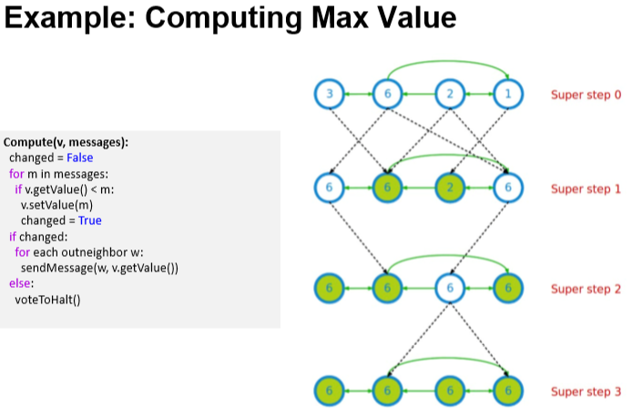

**Pregel: Implementation**

* **Architecture**:
  + Pregel uses a master-worker architecture, where vertices are hash-partitioned and assigned to workers (edge cut)
  + 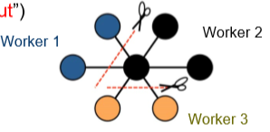Each worker maintains the state of its portion of the graph in memory
  + Computations happen in memory
  + In each super step, workers loop through its vertices and execute compute()
  + Messages can be sent to vertices within the same worker or to different workers, with batching to reduce network traffic​​.
* **Fault Tolerance**
  + Pregel ensures fault tolerance through checkpointing, saving the state of computation to persistent storage periodically.
  + Workers are monitored with heartbeats, and any failure is addressed by reassigning the tasks of the failed workers and reloading their state from checkpoints.

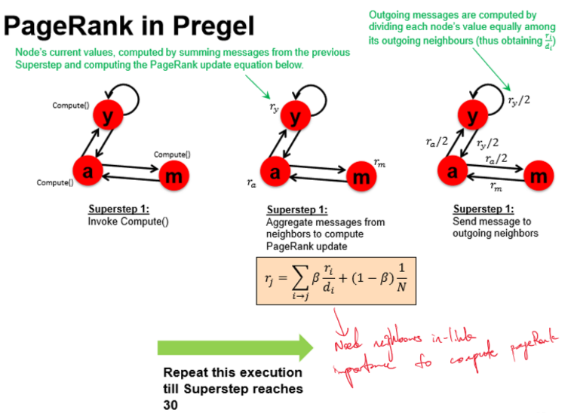

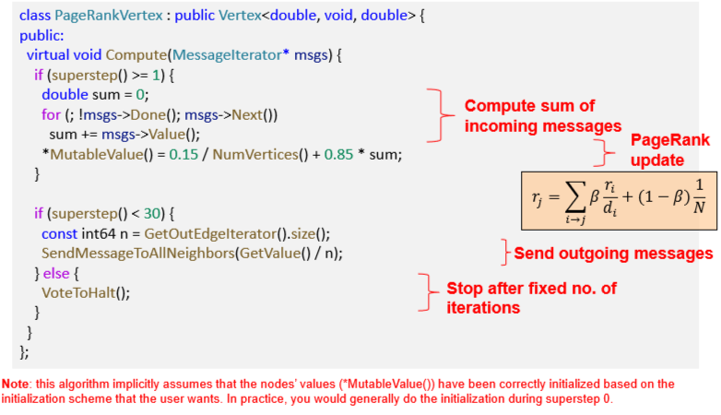

**Other Graph Processing Projects​​**

* **Giraph:** An open-source implementation of the Pregel model developed by Facebook. It is designed to work at scale, processing large-scale graphs.
* **Spark GraphX/GraphFrames:** 
  + Extends Resilient Distributed Datasets (RDDs) to Resilient Distributed Property Graphs.
  + Utilizes Vertex Table and Edge Table to capture relationships within the graph.

**Neo4j:**

* A graph database system that combines graph database functionality with graph processing capabilities.
* Provides a SQL-like interface through its Cypher Query Language, allowing for complex graph queries and operations.

**Performance Comparison**

**GraphX:** According to a 2015 paper, GraphX is capable of achieving performance parity with specialized graph systems. This suggests that GraphX, which is part of the Apache Spark ecosystem, can handle graph processing tasks as efficiently as systems that are exclusively dedicated to graph processing.

**Giraph:** A 2016 efficiency comparison made by Facebook on a trillion-scale social graph indicated that Giraph, being an implementation of Pregel, is suitable for massive graph processing tasks and can handle the complexities of a social network's graph with efficiency.

**Lecture 10 – Evolution of Data Architectures**

Evolution of Data Architectures over the years

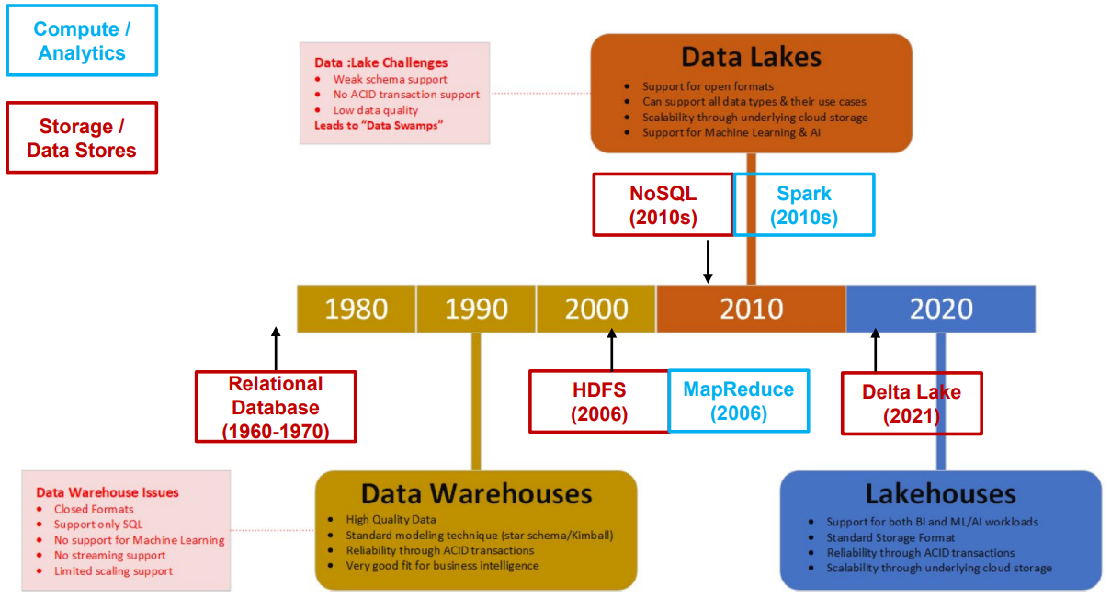

**Database:**

* Designed to store structured data, typically in tables.
* Data can be accessed and manipulated using SQL queries.
* Adherence to a strict schema
  + Allows DBMS to heavily co-optimize data storage and processing through optimized query processing engines
* Features fast and strong transactional ACID (Atomicity, Consistency, Isolation, Durability) guarantees.
* Mainly for Online Transaction Processing (OLTP)

**Data Warehouse:**

* Serves as a central relational repository for integrating historical data from multiple sources.
* Utilized primarily for business intelligence and reporting.
* Implements dimensional modelling techniques and typically modelled using star-schema.

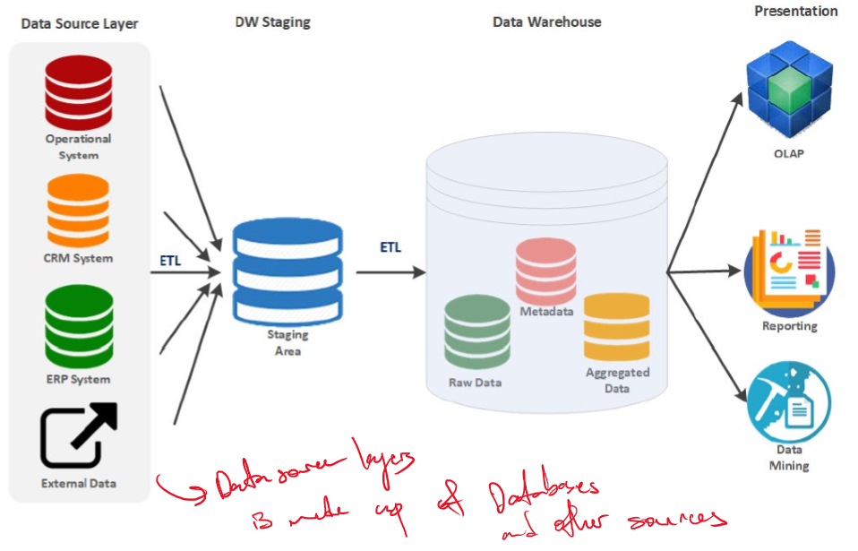

**Data Warehouse Benefits & Challenges:**

* **Benefits**:
  + Reliability,
  + capacity to store large amounts of historical data,
  + strong transactional ACID guarantees.
* **Challenges**:
  + Difficulty supporting non-SQL based analytics,
    - Data warehouses are designed for structured data with a predefined schema. As data volume grows, especially with varied formats, managing and optimizing this structure can become increasingly complex.
  + Expensive to scale
    - Earlier data warehouses were often deployed on-premises with a fixed set of hardware resources. Scaling up to handle increased data volumes or query loads required significant hardware upgrades, which can be costly and time-consuming.
    - There's a limit to how much you can upgrade a single server (vertical scaling) in terms of processing power, memory, and storage, which traditional data warehouses often rely on.

**Data Lake:**

* A cost-effective central repository for storing data at any scale.
* Utilizes distributed storage solutions running on commodity hardware, easily scalable horizontally
* Data is saved in files with open formats, accessible by various processing engines.
* Decouples storage from computing, allowing independent scaling between different computational and storage needs
* Choices for storage systems include
  + HDFS, S3, and Cloud,
  + with file formats ranging from
    - structured (like Parquet and ORC) to
    - semi-structured (like JSON) and
    - unstructured formats (like text, images, audio, video).
* Supports various computing/processing engines, including
  + batch processing
    - (Spark, Presto, Apache Hive)
  + stream processing
    - (Spark, Apache Flink)
  + machine learning libraries
    - (Spark MLlib, scikit-learn, R).
* **Pros of Data Lakes**
  + Flexibility: Data lakes offer flexibility in choosing storage data formats and processing engines.
  + Cost-Effectiveness: They are a much cheaper solution compared to traditional databases, which has led to the explosive growth of the big data ecosystem.
* **Cons of Data Lakes**
  + **Lack of ACID Guarantees**: Data lakes typically do not provide strong ACID (Atomicity, Consistency, Isolation, Durability) guarantees.
  + **Expertise Required**: Building and maintaining an effective data lake requires specialized skills.
  + **High Cost for Data Transformation**: While it's easy to ingest data into data lakes, transforming this data to deliver business value can be expensive.
  + **Data Quality Issues**: Due to the lack of schema enforcement, data lakes can face challenges in maintaining data quality.

**Data Lakehouse**

* A data lakehouse merges the features of data lakes and data warehouses.
* It combines the flexibility, low cost, and scalability of a data lake with the data management and ACID transaction capabilities of data warehouses.
* Particularly suitable for business intelligence, machine learning, and AI applications.
* An excellent match for cloud environments with separate storage and computing resources.

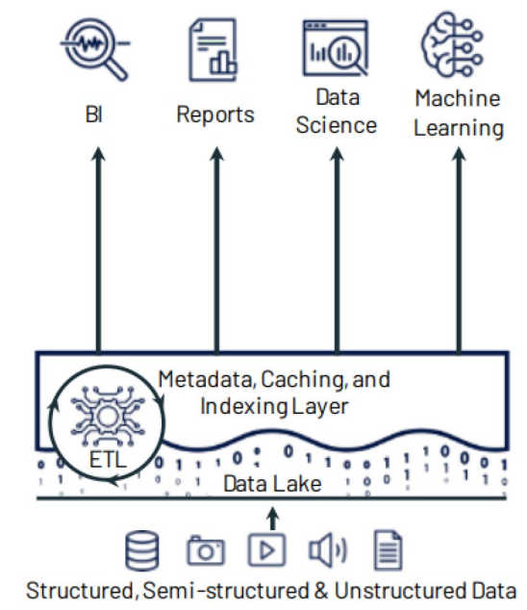 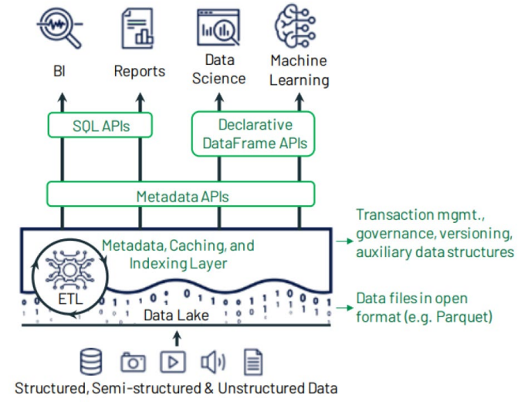

**Delta Lake**

* The metadata, caching and indexing layer on top of a data storage that provides an abstraction level to serve ACID transactions and other management features.
  + Transactional ACID guarantees
  + Full Data Manipulation Language support
  + Audit History
  + Unification of batch and streaming into one processing model
  + Schema enforcement and evolution
  + Rich metadata support and scaling

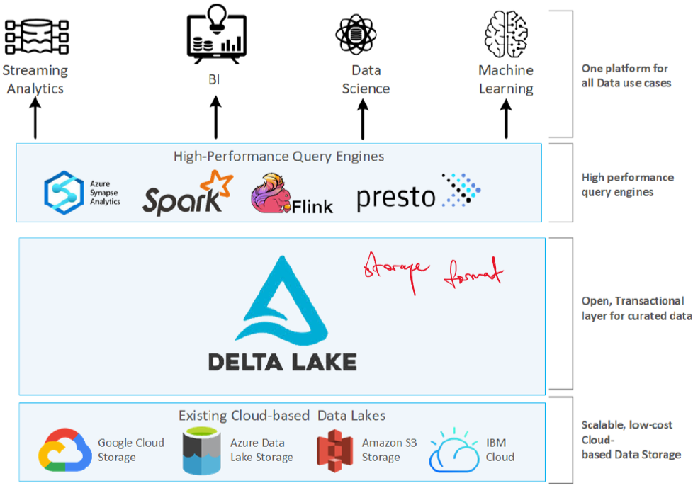

**Delta Lake Format**

* Delta Lake leverages the standard Parquet file format,
  + which is column-oriented,
    - This allows for data compression on a column-by-column basis.
  + open-source, and
  + self-describing.
    - Actual data + metadata (schema & file structure)

**Delta Lake Transaction Log (DeltaLog)​​**

* The Delta Lake Transaction Log is an ordered record of every transaction made against a delta table since it was created
* Serves as a single source of truth and tracks all changes made to the table
  + Single source of truth allows for multiple readers and writers

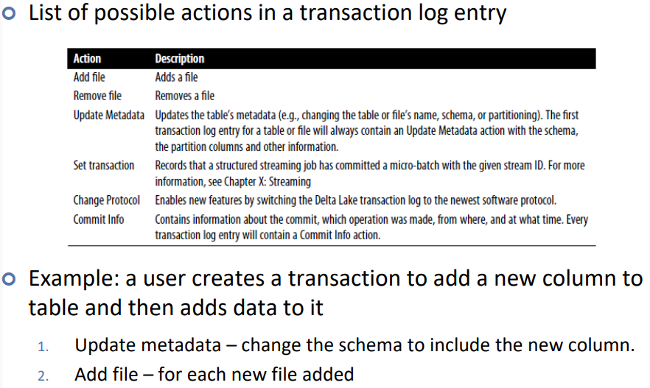

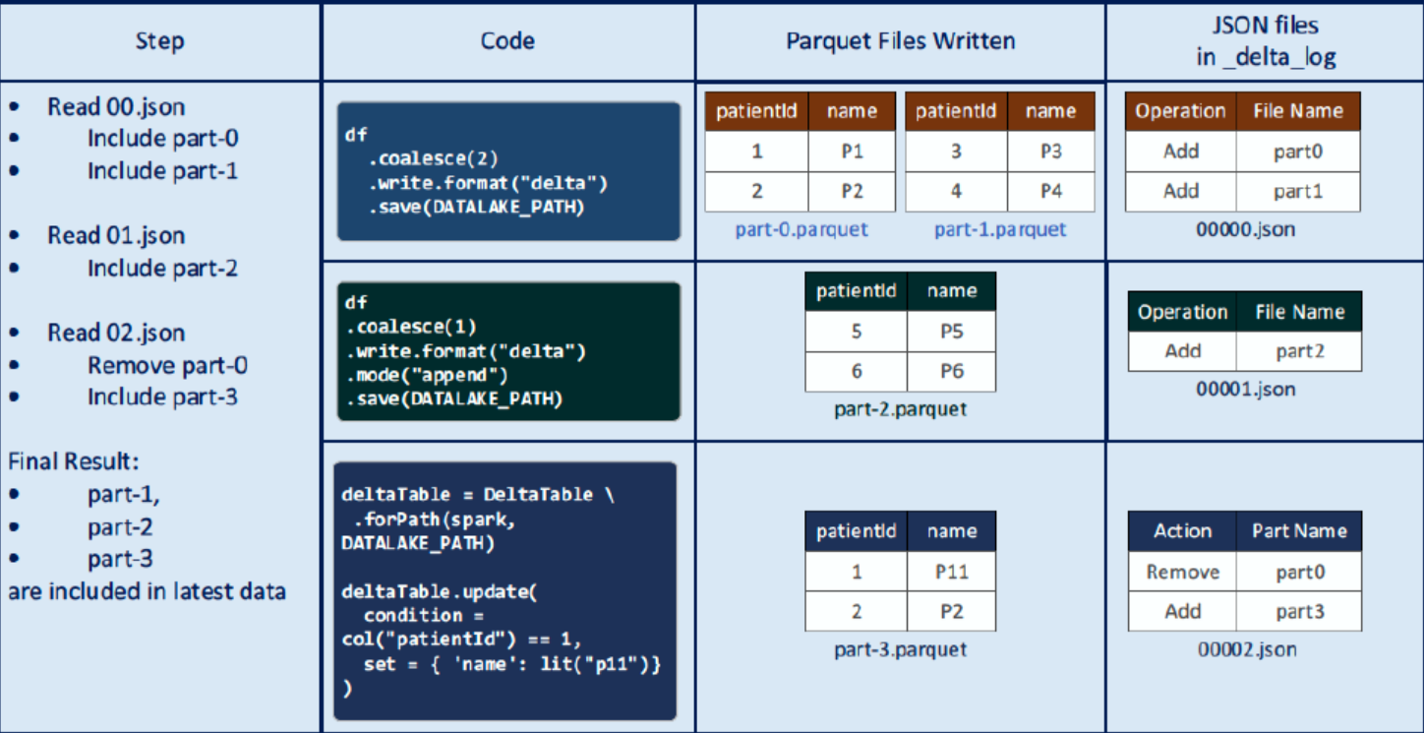

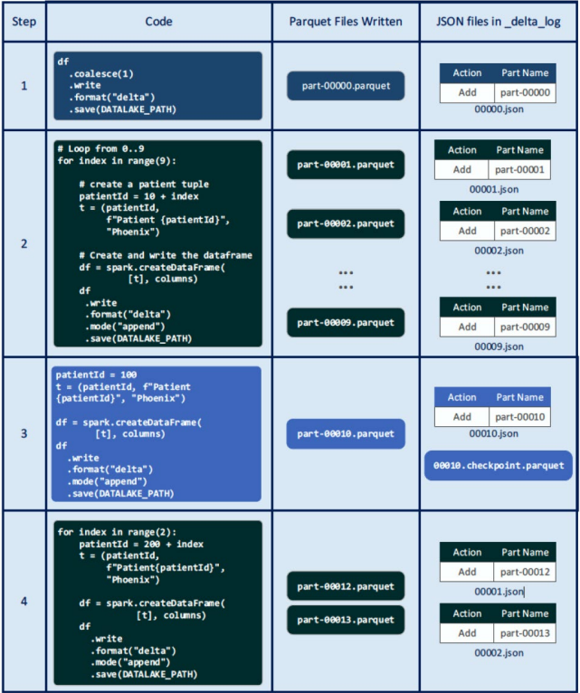

* The delta_log keeps track of which parquet file to read
* Every 10 delta_log.json file, we create a checkpoint to summarize all changes into a single file to reduce the number of reads.

**Lecture 2 – HDFS**

**Distributed File System Philosophy**: Unlike traditional systems where data is moved to the workers, in HDFS, **workers are moved to the data.**

* Data is stored on local disks of nodes in the cluster, and
* workers start up on the node where the data is located.
* This approach reduces network traffic and enhances performance.

Google File System for Google’s MapReduce

Hadoop Distributed File System for Hadoop

**Assumptions of GFS/HDFS:**

* Use of commodity hardware instead of expensive, specialized hardware
  + focus on scaling out (adding more machines)
  + rather than scaling up (upgrading individual machines).
* High component failure rates are expected, given the use of inexpensive hardware.
* The system is optimized for a modest number of large files.
* Files are typically write-once and mostly appended to.
* HDFS favors large streaming reads over random access,
  + high sustained throughput rather than low latency.

**Design Decisions**

* Files in HDFS are stored in chunks (128MB for HDFS, 64MB for GFS)
* Reliability is ensured through replication, with each chunk replicated across three or more chunk servers.
* A single master (namenode) coordinates access and maintains metadata, simplifying centralized management.

**HDFS Architecture**

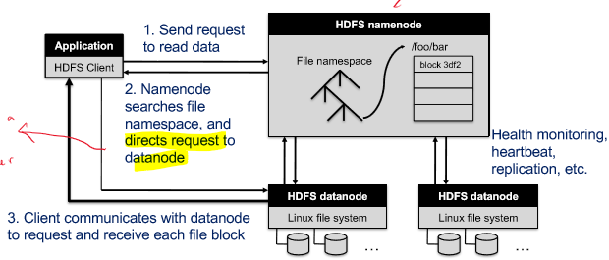

* The HDFS architecture involves an HDFS client, a name node, and data nodes.
* The client sends a request to read data
* The name node, which holds the file system namespace, directs the request to the appropriate data node.
  + Like a DNS server
  + Name node keeps track of
    - File/directory structure
    - Metadata
    - File-to-block mapping
    - Access permissions
* The client then communicates with the data node to request and receive file blocks.
  + No data is moved through the namenode
* The name node is responsible for
  + health monitoring,
  + heartbeat checks,
  + replication,
  + rebalancing
  + garbage collection
* The replication process is managed by the namenode, which decides which datanodes serve as replicas. The first datanode forwards data blocks to the first replica, which in turn forwards them to the second replica, and so on.

